Republic of the Philippines

Polytechnic University of the Philippines

**College of Computer and Information Sciences**

Sta. Mesa, Manila

**Technical Documentation of a Generic Attendance Monitoring and Equipment Management for Construction Company**

A System Study Presented to the Faculty of the

College of Computer and Information Sciences

Polytechnic University of the Philippines

Submitted by:

Anapi, Christopher

Cruz, Carlson

Pascual, Jan Marc

Reves, Rosary Lee

Varde, Kim Denzell

BSIT 4-3

# **Chapter 1: Abstract/Overview**

## 1.1 Project Definition / INTRODUCTION – Problem/Opportunity Statement

A construction company delivers construction projects and services that meet the local and international standard. They keep their track on their employees performing a specific job on a site they were assigned. Most company currently uses manual forms as a way of transaction. They maintain their inventory on logbook for tracking and monitoring purposes.

Their reports, whether daily, weekly, monthly, or annually are manually encoded with a use of a spread sheet or word processing software and prints it for presentation purposes.

The proposed project will addressed the following problems:

* Inconsistent monitoring and tracking of asset and attendance.
* Slow processing of data specifically in time keeping.
* Data redundancy due to duplication of copies.
* Time-consuming on searching for specific records.
* Unmanaged details/information of workers.
* Worker and task mismatch.

## 1.2 BUSINESS CASE

**1.2.1 Project Goal**

* The project will lessen the inaccuracy of distributing the assets.
* The project will improve the reliability of records and completeness of reports.
* The project will resolve the inconsistency in time and attendance monitoring.
* The project will minimize the time in searching for past records.

**1.2.2 Project Objective**

* To provide a module that will appropriately assign workers to their fitted job.
* To provide a module that will accurately assign the needed equipment in a project.
* To provide a module in system that will allow users to generate reports.
* To provide reports that will summarize the business services and transactions.
* To provide a tool from a system that will store data into database.
* To provide a web based system that could be easily accessed by any devices using an internet browser.
* To provide a system that can easily query past records.
* To provide a system that allows the user to monitor worker’s time and attendance.
* To provide a system that gives actual time-in/time-out of the workers.

**1.2.3 Assumptions**

The assumptions for this project are as follows:

* Resource requirements will be available when needed.
* All necessary documents and information will be provided by the client.
* Team members will maximize the time given in making the project.
* Team members will contribute and finished their tasks (with quality) on time and abide by the schedule of completion.
* The project will help in the improvement of business process of the company.
* The project will be of solution to the company’s problems.
* Project problems and risks will be handle and taken into action once occur.

**1.2.4 Constraints**

The major constraints in developing the system are:

* Time - Allotted time provided in the semester is short and other school requirements and responsibilities must be met on the course of the project. The team must set start and end date for a specific task and produce of quality results.
* Budget - Each of the team members has a limited budget to spend since the allowances are only for food and transportation for school days, other miscellaneous fees such as printing documents and transportation fare for meeting clients are not included in the budget.
* Scope - The Scope of the system is limited only to Generic Attendance Monitoring and Equipment Management for Construction Company.
* Limited knowledge.

**1.2.5 Methods Used in the Study**

* We gather information by interviewing and by giving questionnaires to our client and its employees.
* We used Agile Methodology Development Strategies, so we can make changes in case the client wants to improve or add more features.
* We also have prepared a Process Flow Diagram (PFD) and Fishbone Diagram to see clearly their problems that we can work on.

# **Chapter 2: Functional Specification Report**

## 2.1. Data Requirements

**2.1.1 Forms**

**2.1.1.1 List and Description of Forms**

|  |  |  |
| --- | --- | --- |
| **Name of Form** | **Description** | |
| Attendance Form  (Figure 2.1) | Attendance Sheet of workers this also include the material and the equipment brought in the site | |
| Inspection request  (Figure 2.2) | Final inspection Request After Hand Over Report |  |
| Project Manager Instruction(PMI)  (Figure 2.3) | Instruction about what has to be done in the project |  |
| Site Memorandum  (Figure 2.4) | Memo about the site with attachment of the key plan. |  |

**Table 2.1 List of Forms**

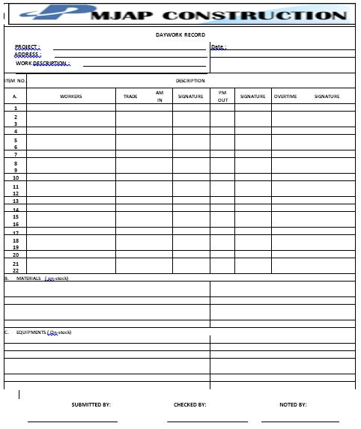**2.1.1.2 Layout of Forms**

**Figure 2.1 .1 Attendance Form**

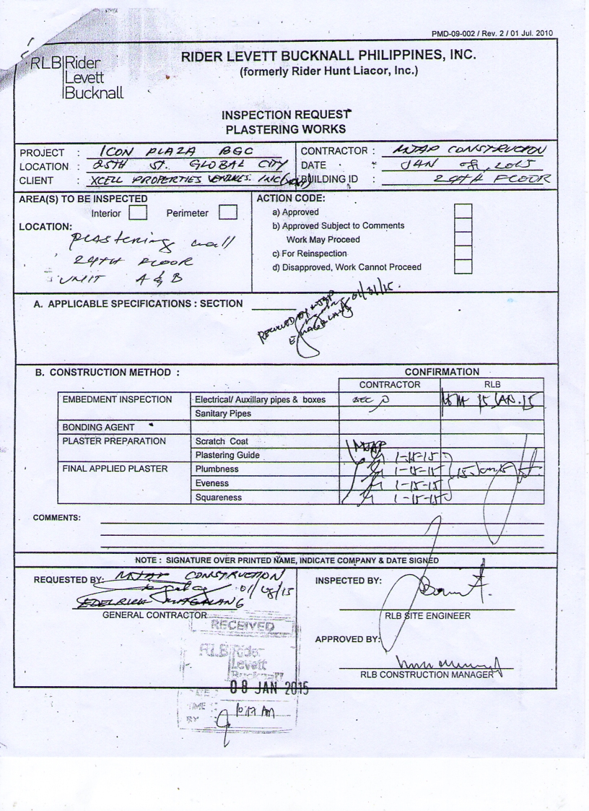

**Figure 2.1.2 Inspection Request Form**

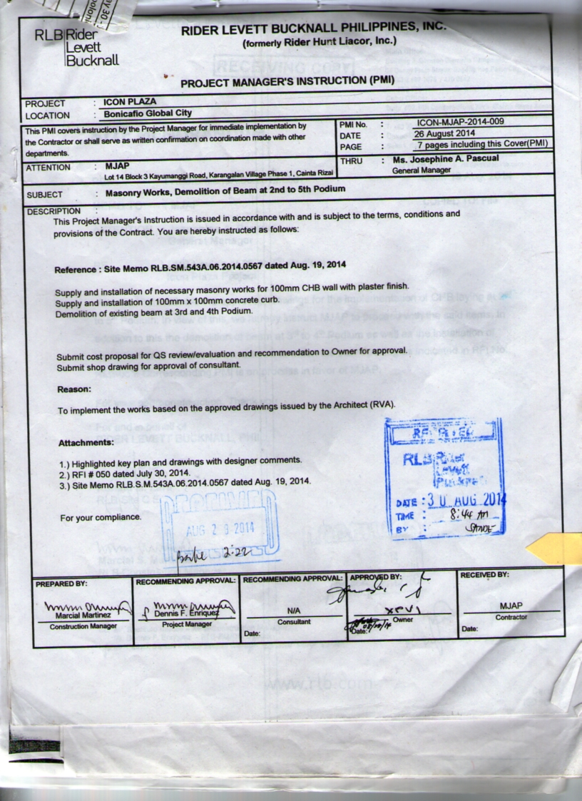

**Figure 2.1.3 Project Manager’s Instruction Form**

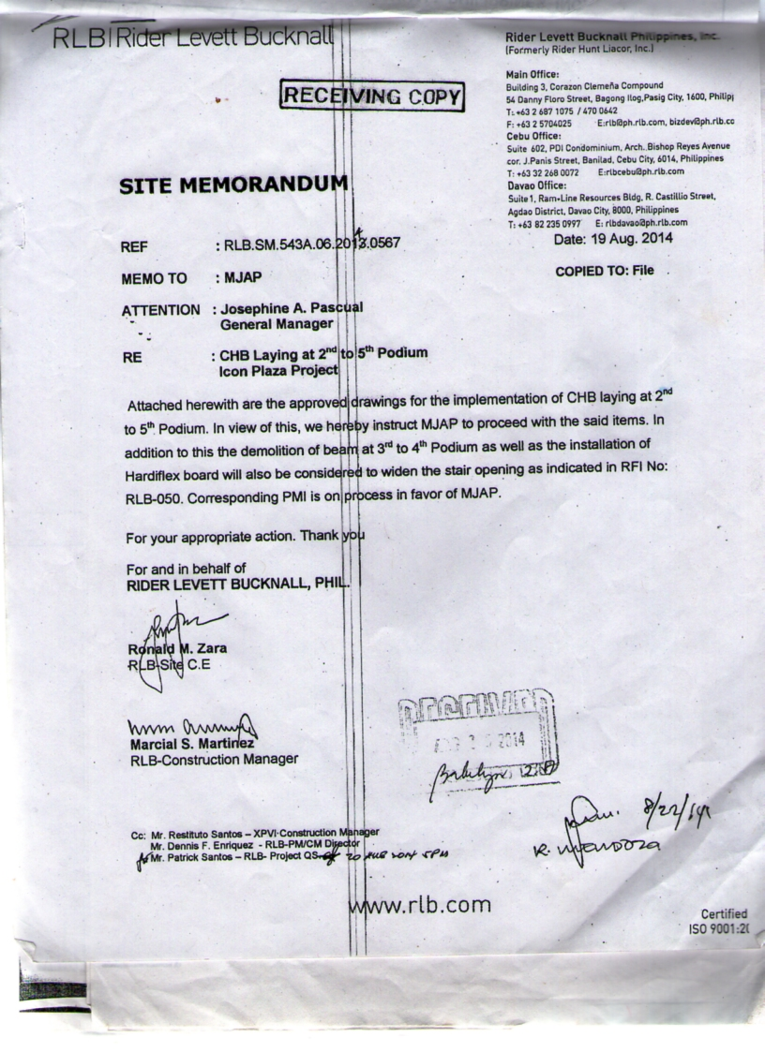

**Figure 2.1.4 Site Memorandum Form**

**2.1.2 Reports**

**2.1.2.1 List and Description of Reports**

|  |  |
| --- | --- |
| **Name of Report** | **Description** |
| Weekly Accomplishment Report  (Figure 2.5, 2.5.1 and 2.5.2) | Accomplishment Report in a Week |
| Monthly Accomplishment Report  (Figure 2.6, 2.6.1 and 2.6.2) | Accomplishment Report in a month |
| Contractor’s Daily Report  (Figure 2.7 and 2.7.1 | This includes:   * Daily Work Description * Event’s Visitor to the site and/or important issues * Works to be accomplished the following day * Review of schedule * remarks |

**Table 2.2 List of Reports**

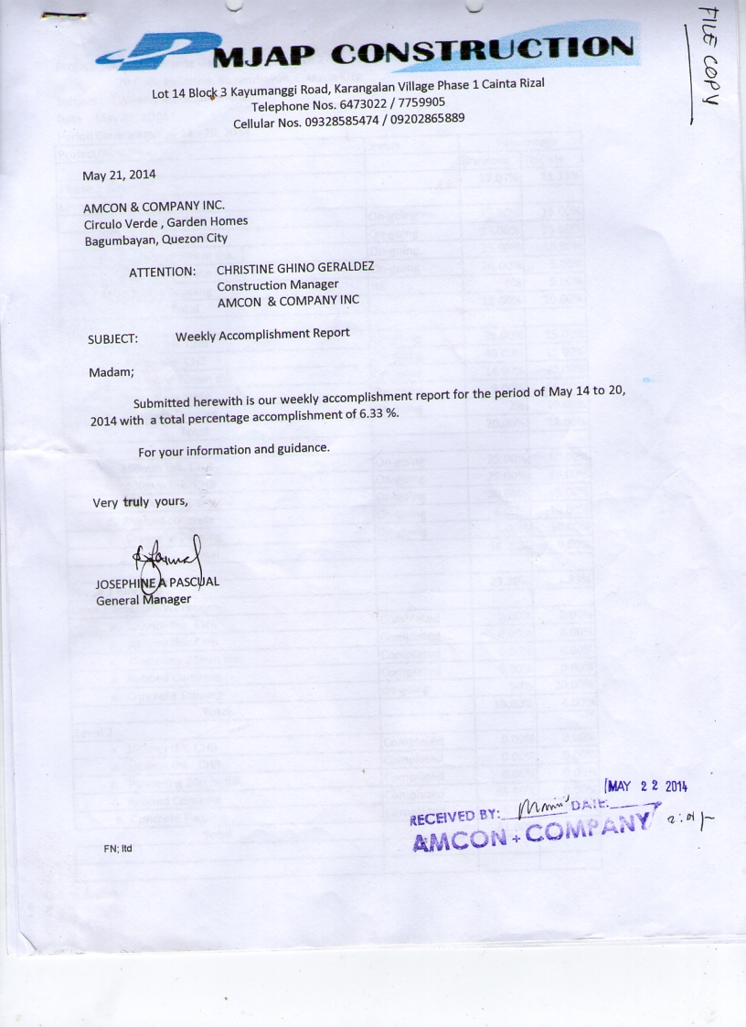**1.2.2 Layout of Reports**

**Figure 2.1.5 Weekly Accomplishment Report**

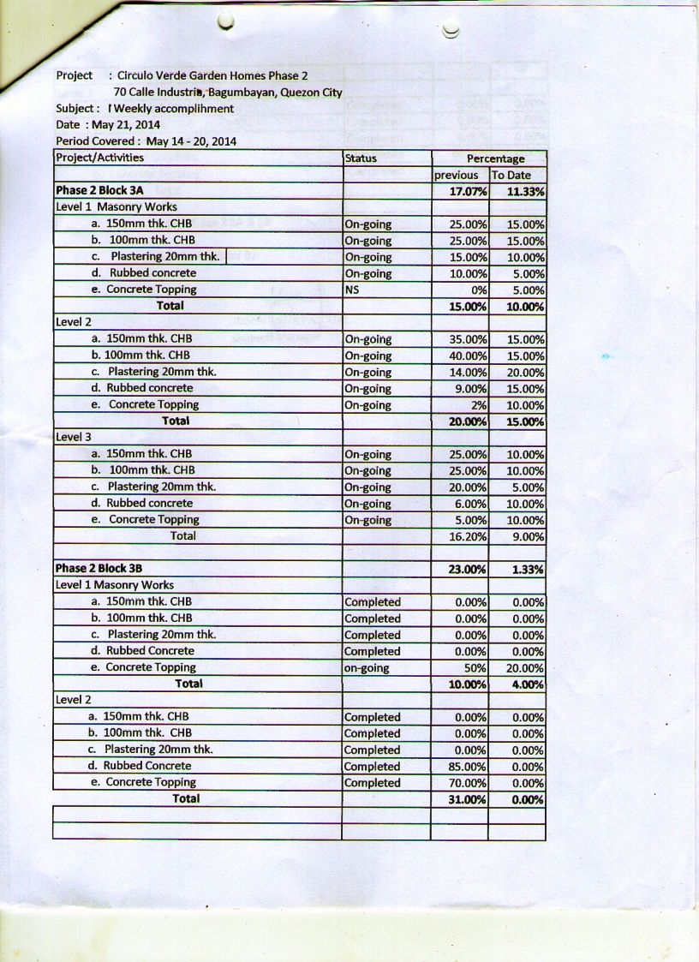

**Figure 2.1.5.1 Weekly Accomplishment Report**

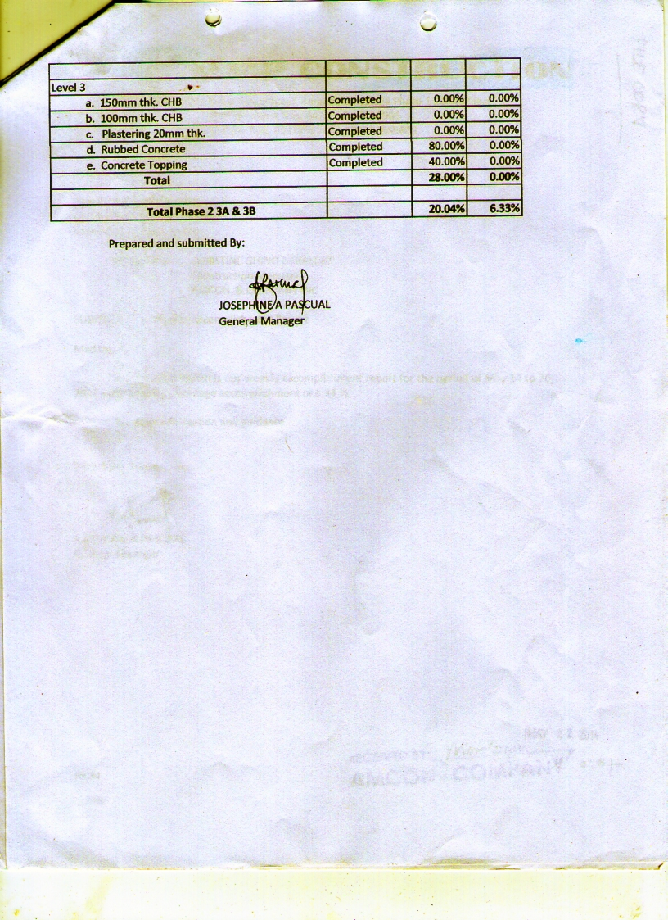

**Figure 2.1.5.2 Weekly Accomplishment Report**

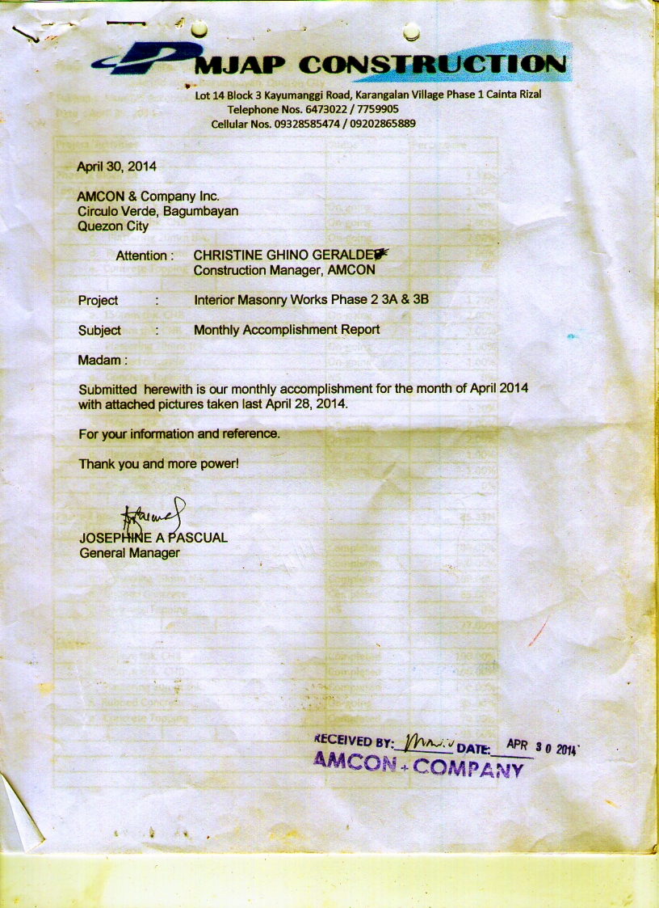

**Figure 2.1.6 Monthly Accomplishment Report**

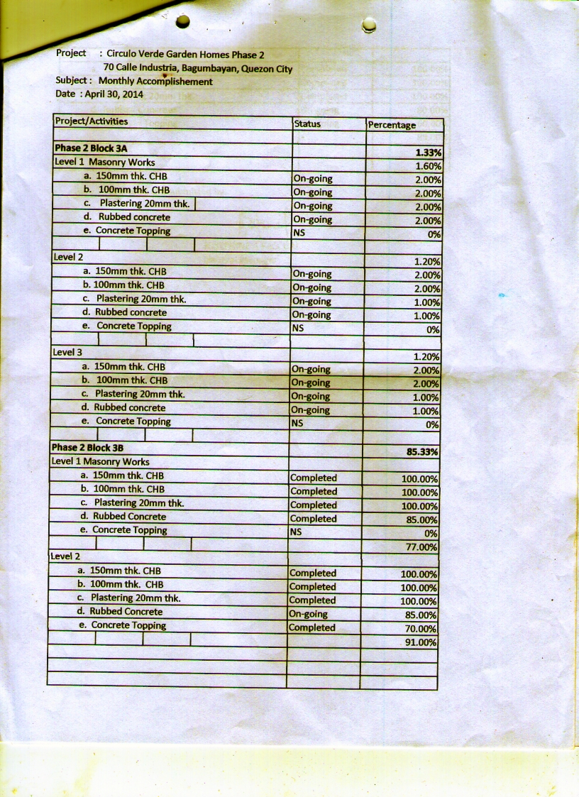

**Figure 2.1.6.1 Monthly Accomplishment Report**

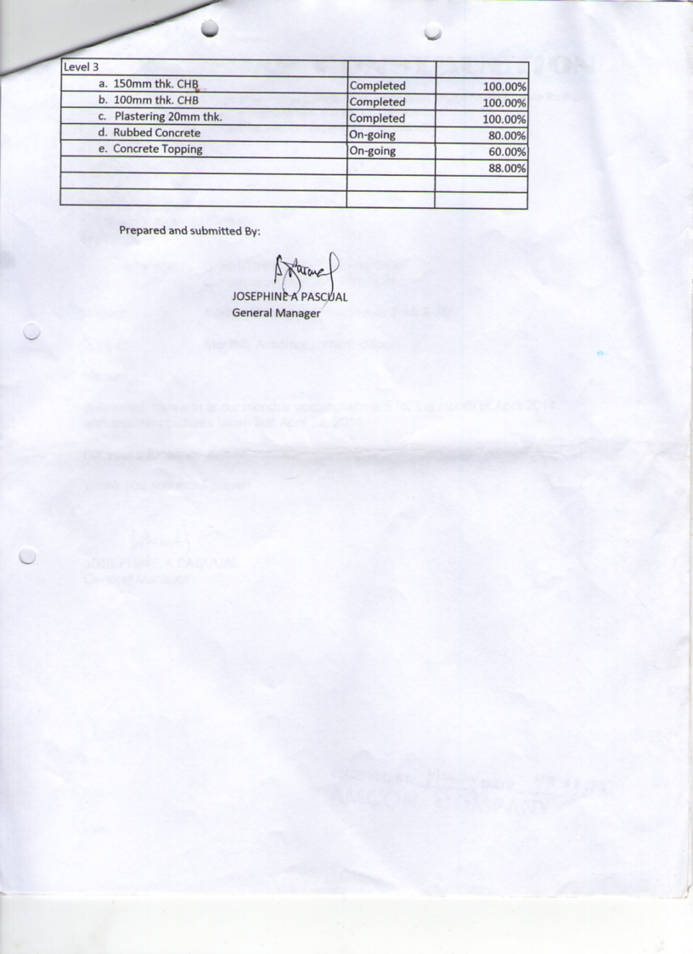

**Figure 2.1.6.2 Monthly Accomplishment Report**

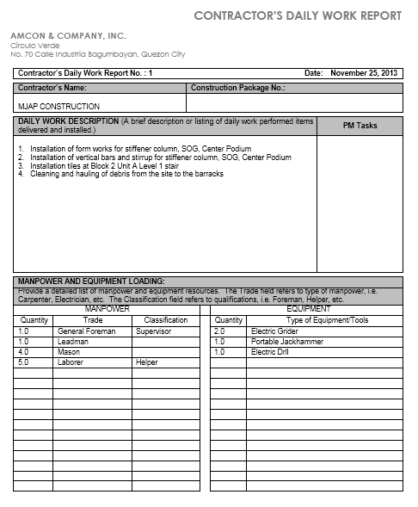

**Figure 2.1.7 Contractor’s Daily Work Report**

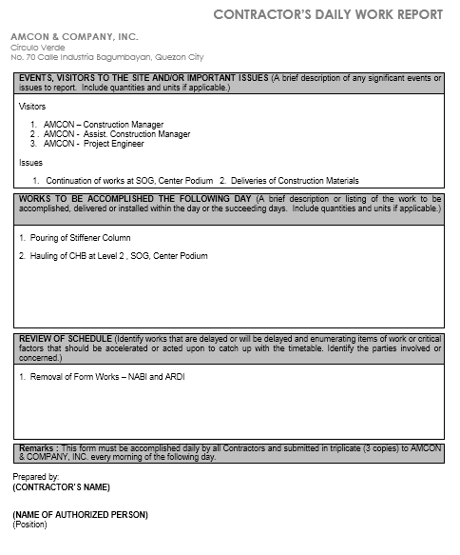

**Figure 2.1.7.1 Contractor’s Daily Work Report**

## 2.2 Policies and Procedures

**2.2.1 Procedures**

**2.2.1.1 Context Diagram**

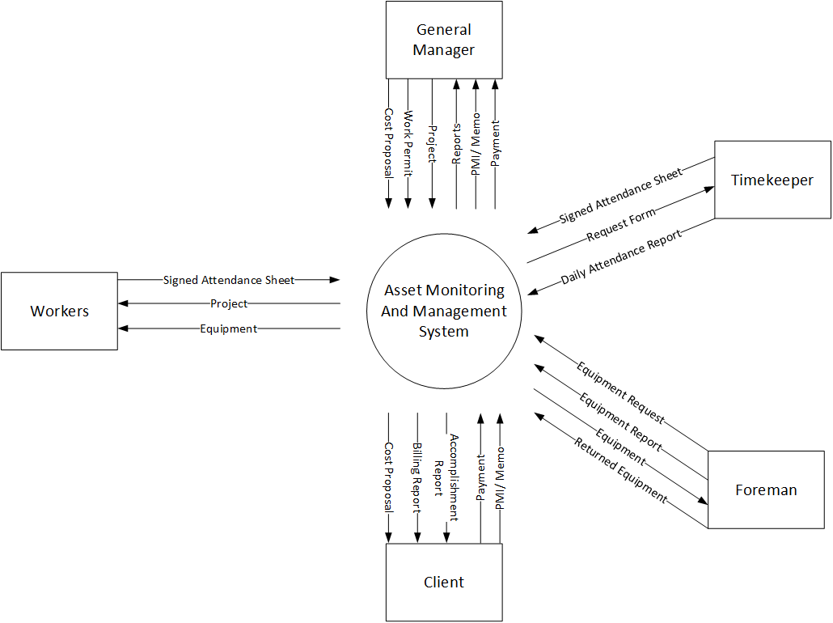

**2.2.1.2 Level 1 DFD**

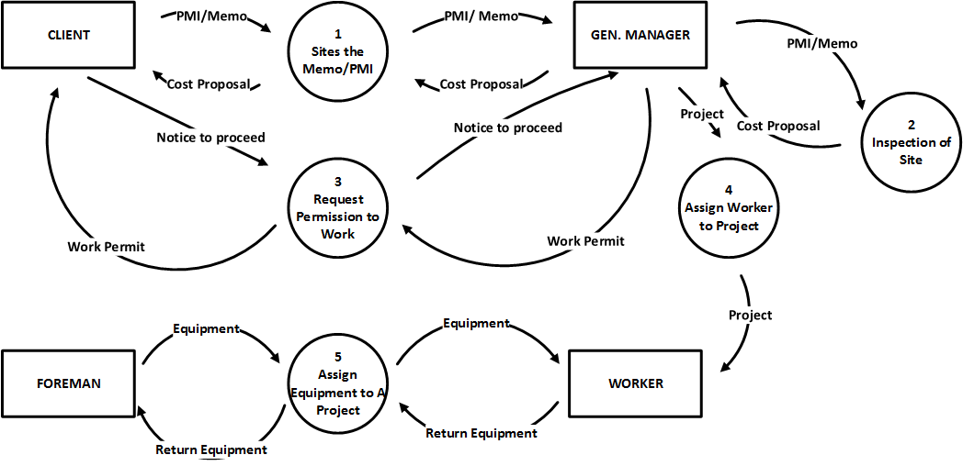

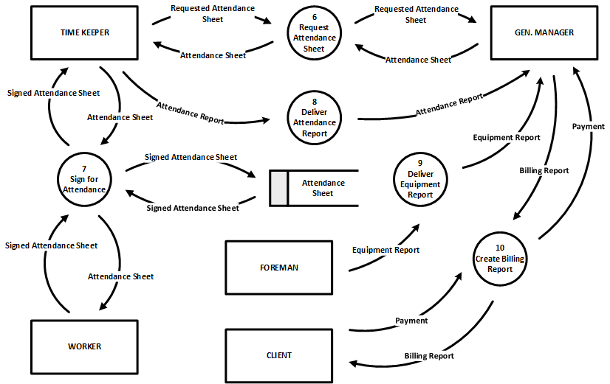**2.2.2 Policies**

**2.2.2.1 Business Requirements**

|  |  |
| --- | --- |
| Business Requirements ID | Description |
| BR – 001 | The client must have the following requirements:   * Copy of lot title or lot plan; either present or previous Owner * If lot is not owned; affidavit of consent from owner or contract of sale or lease contract * Tax declaration * Latest tax receipts * Owner’s or building permit applicant’s Community Tax Certificate (cedula) * Lot survey c/o subdivision * Soil exploration or soil bore test if project is 3 floors and above * Barangay clearance specific for construction * If Building permit applicant does not stay in Philippines, Special Power of Attorney (for construction purpose) |
| BR – 002 | The General Manager shall check if the documents is valid |
| BR – 003 | The client must submit the following requirements to the General Manager:   * Project Manager Instruction(PMI) * Project Memorandum * Permit to work |

**2.2.2.2 Business Rules**

|  |  |
| --- | --- |
| Business Rule ID | Description |
| BR – 1 | The applicant must have knowledge about construction |
| BR – 2 | The applicant must submit the following requirements to the General Manager:   * Certificate of last work * Birth certificate |
| BR – 3 | The applicant must have skills to be put in the mason category of workers |
| BR – 4 | If the worker will take a leave, he must notify the General Manager or the General Foreman at least 2 -3 days before |
| BR – 5 | If the worker is absent they must submit a valid reason and if there’s any they must submit a medical certificate |

## 2.3. Problem Analysis

**2.3.1 Fishbone Diagram**

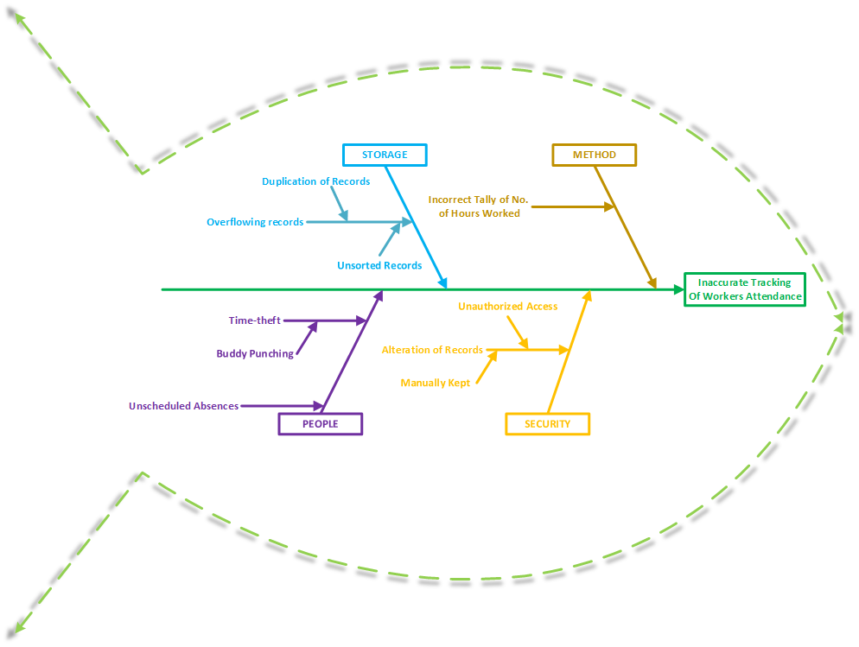

**Fig. 2.3.1 Attendance Fish Bone**

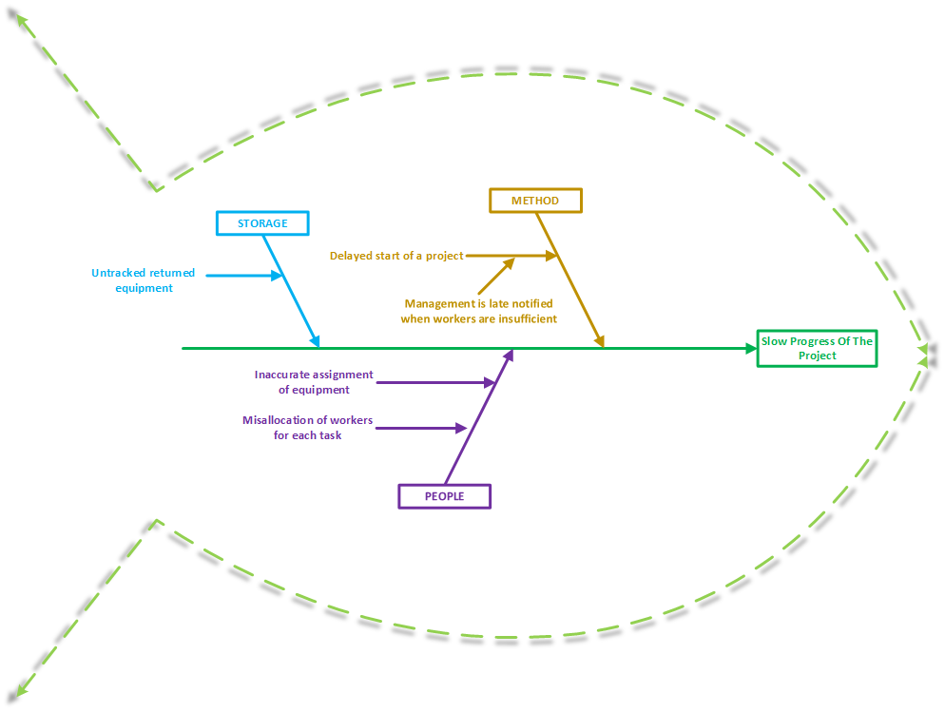

**Fig. 2.3.2 Asset Management Fish Bone**

**2.3.2 Conclusion and Recommendation**

**2.3.2 .1 Conclusion**

The project team concludes that the company’s manual procedures develop problems in tracking and managing their asset. Unmanaged deployment of workers and equipment sometimes causes delay in progress of the project. Their manual processing makes it prone to losing papers developed from day to day operations. Producing multiple copies as back up makes overflowing and redundant records, which makes it more difficult to update and search for past records. Producing reports takes a lot of time because of manual retrieval and access to required documents.

Long distance between sites to their main office causes delays in processing information and because the documents are just written in papers, it takes a long time in presenting it to respective authority.

**2.3.2 .2 Recommendation**

Concluding on what the project team has studied and gathered, we recommend to our client a computer web based system of Asset Monitoring and Management System. This computerized system will help manage the assignment of equipment and workers to their specific task and schedules the worker’s leave to improve their overall productivity. It will provide a secured storage of the company’s information that will be authorized by specific users. The system will help the users to search and update past records. The system will also help the users to generate reports easily by having a repository or module.

The system is web based, so we recommend the user’s familiarity in operating a web based system for better utilization and recognition of the system. The computerized system is user friendly so it is understandable and easy to use.

# **Chapter 3: Proposed System Definition**

## 3.1 Functional Specification

**3.1.1System Boundaries**

**3.1.1.1 System Use Case Diagram**

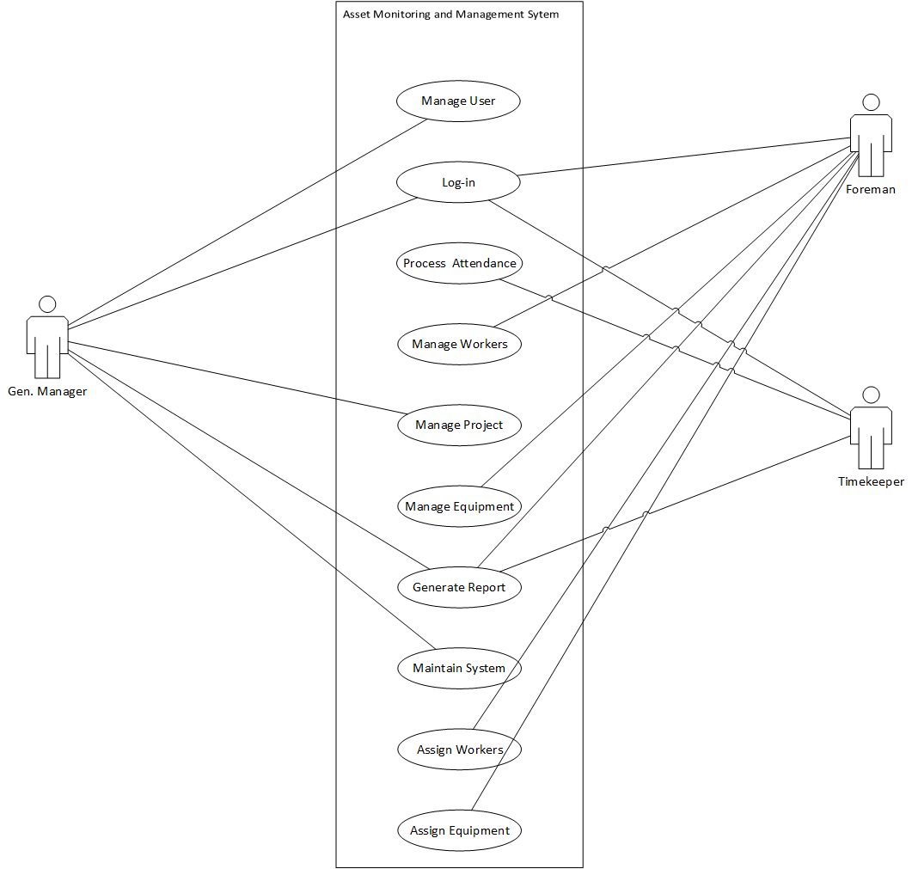

**Figure 3. 1. 1 Use Case**

**3.1.1.2 Detailed Use Case Diagram**

**Detailed Use Case for Log-In**

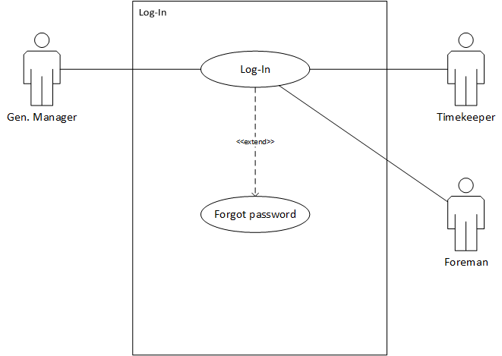

**Figure 3. 1. 2 Detailed Use Case – Log In**

**Detailed Use Case for User**

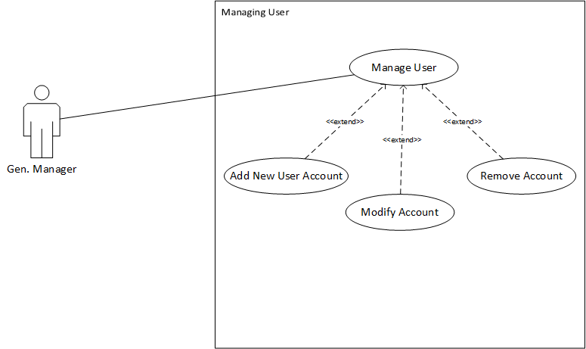

**Figure 3. 1. 3 Detailed Use Case – User**

**Detailed Use Case for Project**

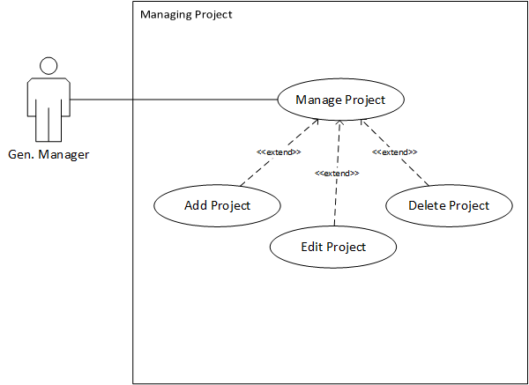

**Figure 3. 1. 4 Detailed Use Case – Project**

**Detailed Use Case for Worker**

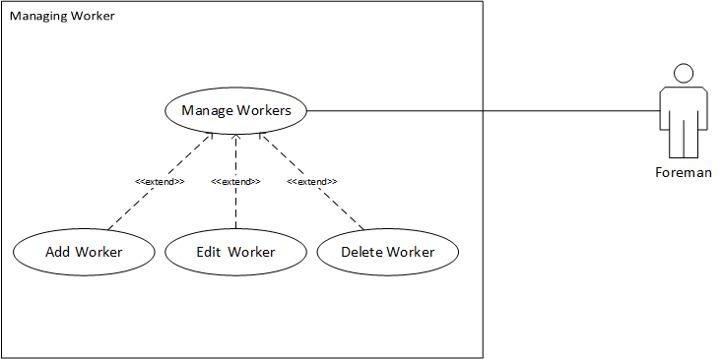

**Figure 3. 1. 5 Detailed Use Case – Worker**

**Detailed Use Case for Equipment**

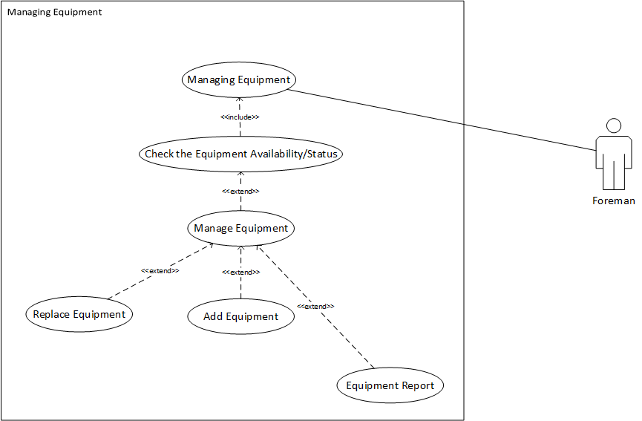

**Figure 3. 1. 6 Detailed Use Case – Equipment**

**Detailed Use Case for Assigning**

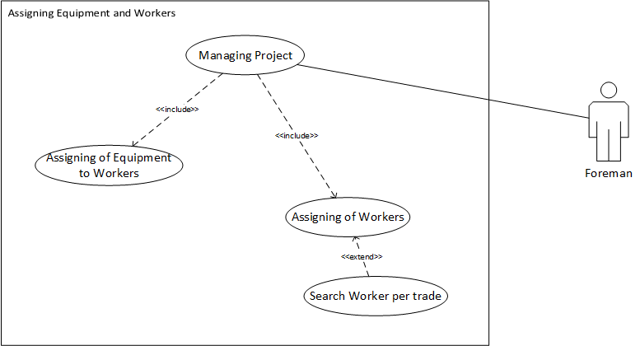

**Figure 3. 1. 7 Detailed Use Case – Assigning**

***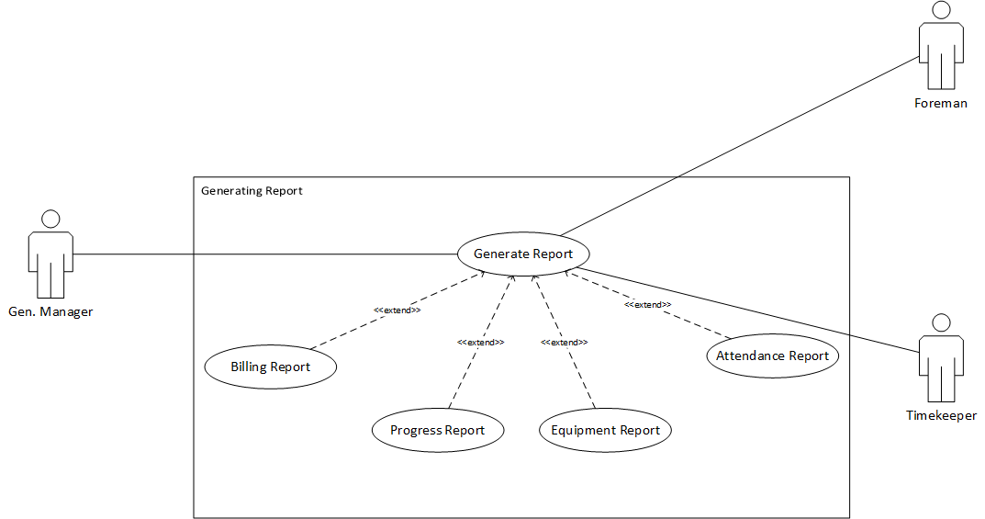*Detailed Use Case for Report**

**Figure 3. 1. 8 Detailed Use Case –Report**

***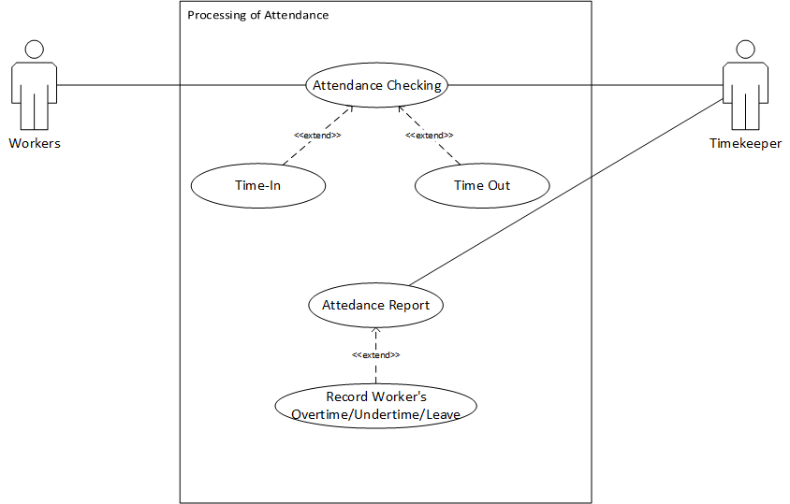*Detailed Use Case for Attendance**

**Figure 3. 1. 9 Detailed Use Case – Attendance**

***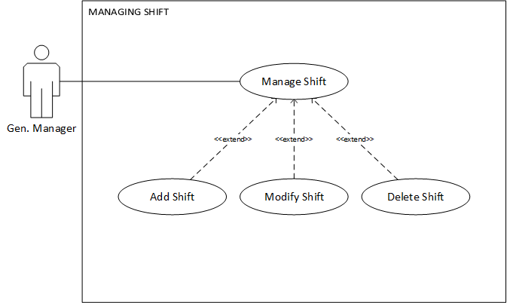*Detailed Use Case for Shift**

**Figure 3. 1. 10 Detailed Use Case –Shift**

**3.1.1.3 System Flow**

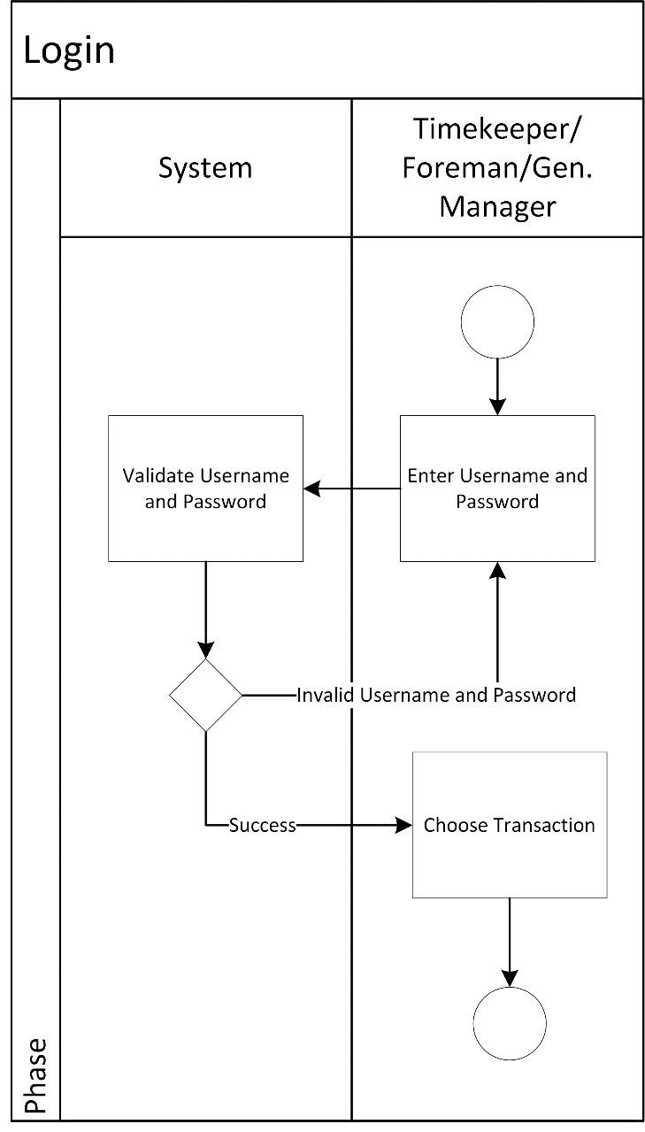

Figure 3. 1. 11 System Flow Diagram - Log-in

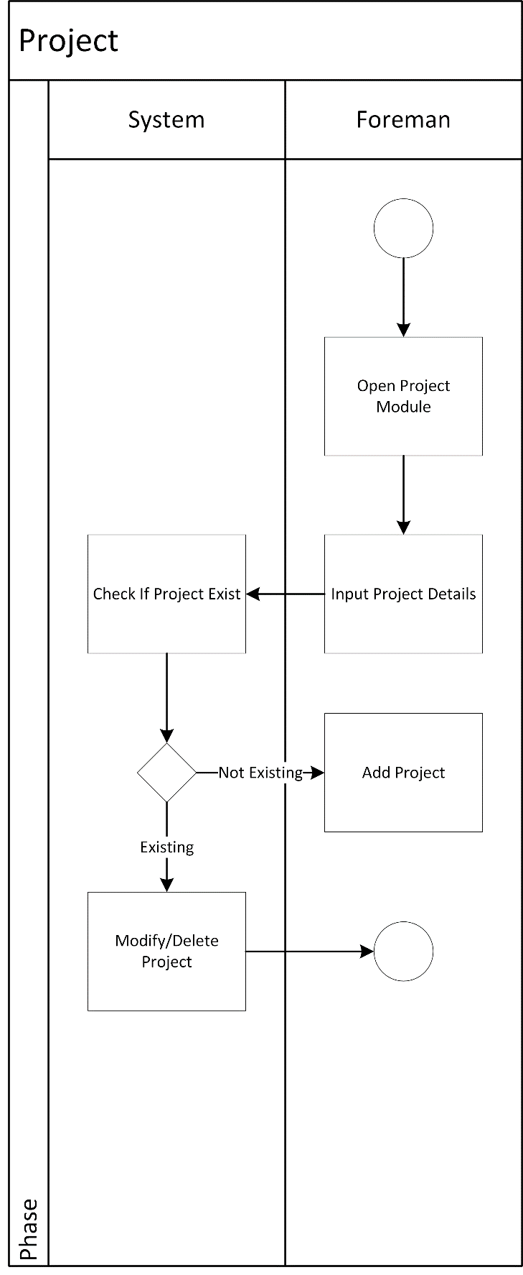

Figure 3. 1. 12 System Flow Diagram – Project

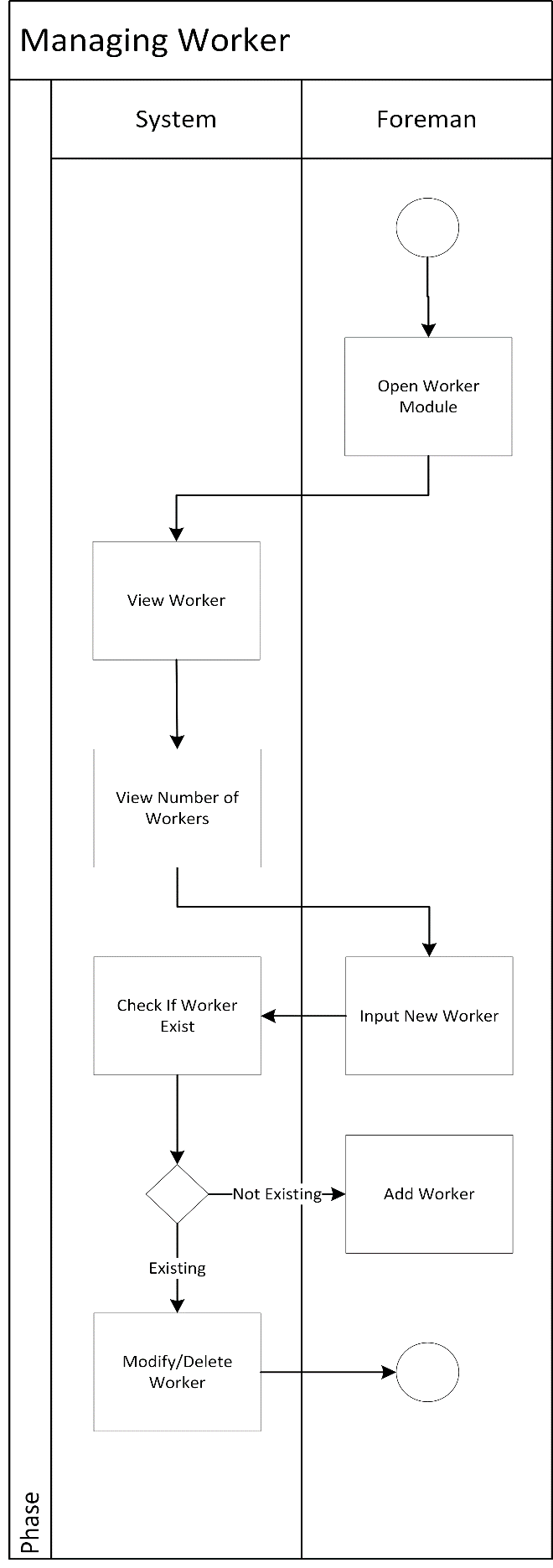

Figure 3. 1. 13 System Flow Diagram – Worker

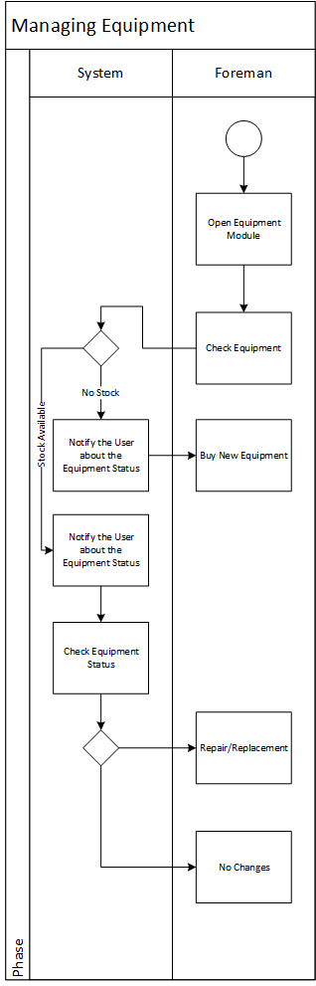

Figure 3. 1. 14 System Flow Diagram – Equipment

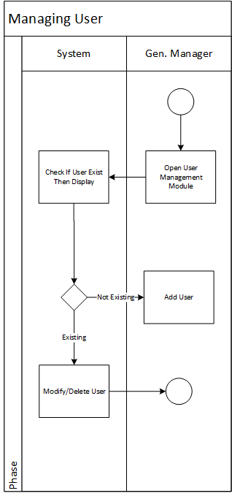

Figure 3. 1. 15 System Flow Diagram – User

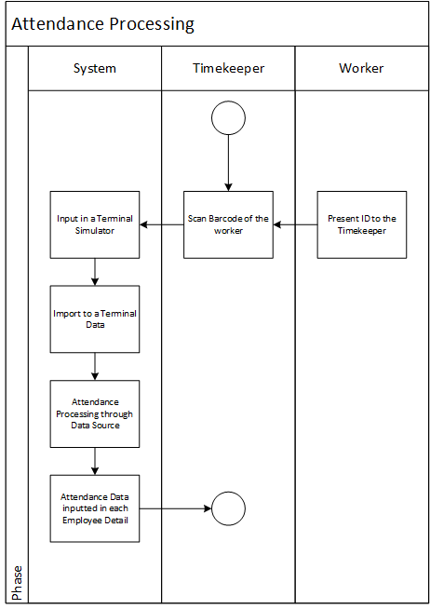

Figure 3. 1. 16 System Flow Diagram – Attendance

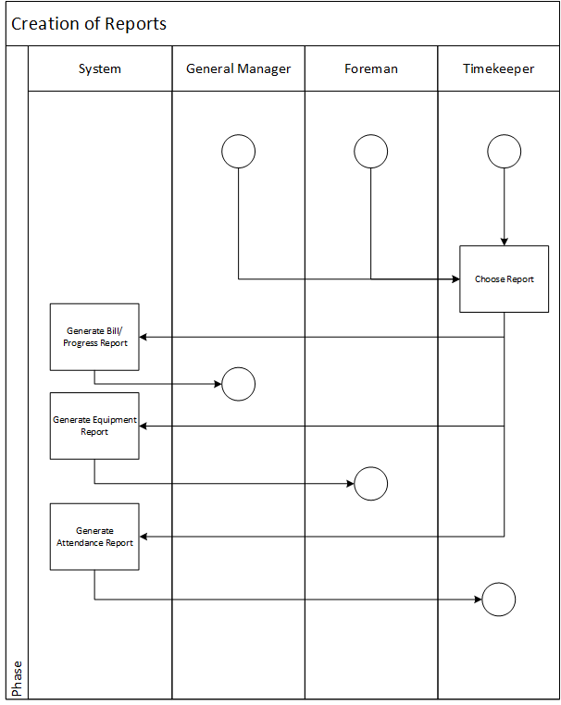

Figure 3. 1. 17 System Flow Diagram – Report

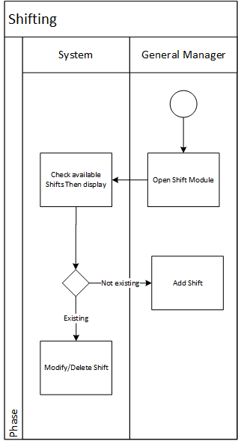

Figure 3. 1. 18 System Flow Diagram – Shifting

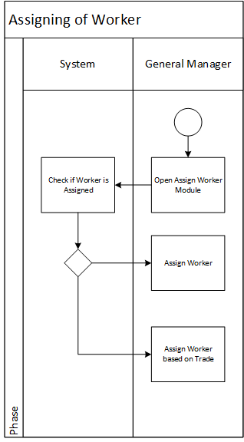

Figure 3. 1. 19 System Flow Diagram – Assigning of Worker

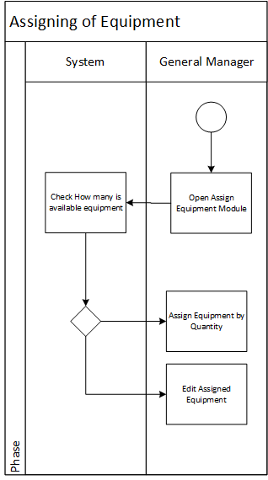

Figure 3. 1. 20 System Flow Diagram – Assigning of Equipment

**3.2 Technical Specification**

**3.2.1 Domain Object Modelling**

**3.2.1.1 Data Dictionary of Classes**

|  |  |
| --- | --- |
| Class | Description |
| ATTACHMENT | This contains all documents attached in a project |
| PROJECTATTEND | This contains the attendance of all projects |
| CLIENT | This contains the information about the client |
| CLIENTSTAFF | This contains the contact of the client in a project |
| DAILYATTEND | This contains the daily attendance in a project |
| EQUIPMENT | This contains the equipment information |
| EQUIPCTGRY | This contains the category of the equipment |
| PROJECT | This contains the project information |
| PROJREQEQUIP | This contains the assigned equipment in a project |
| PROJECT_REQUIREMENTS | This contains the constraints in a project |
| ASSIGNEDWORKER | This contains the assigned worker in a project |
| TRADE | This contains what a worker can do |
| USER | This contains the information about who uses the system |
| WORKER | This contains the worker information |
| WORKER_CATEGORY | This contains the category of a worker |
| WORKERTRADE | This contains the assigned skill of a worker |

**Table 3.2.1 Data Dictionary of Classes**

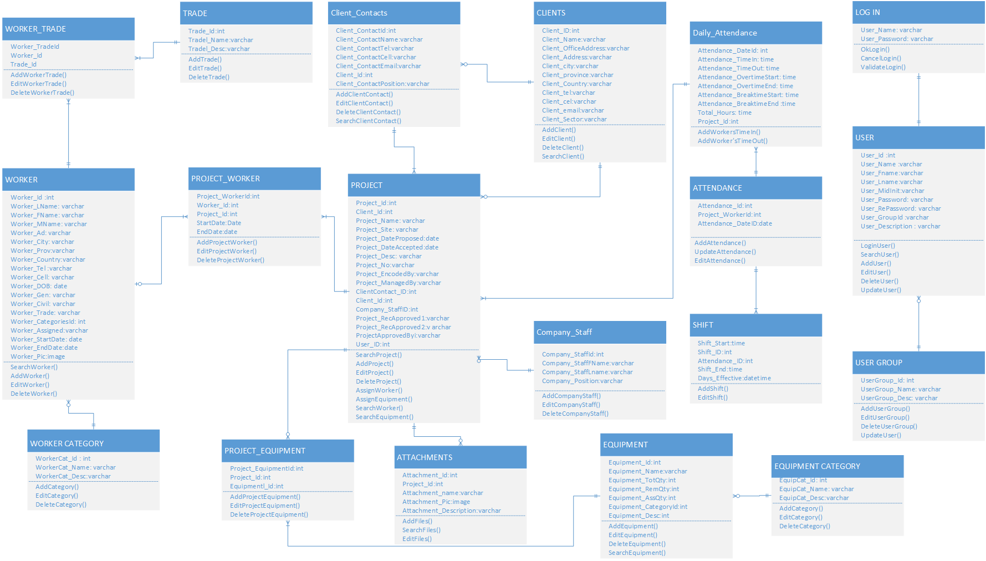**3.2.1.2 Final Class Diagram**

**3.2.2 Database Design**

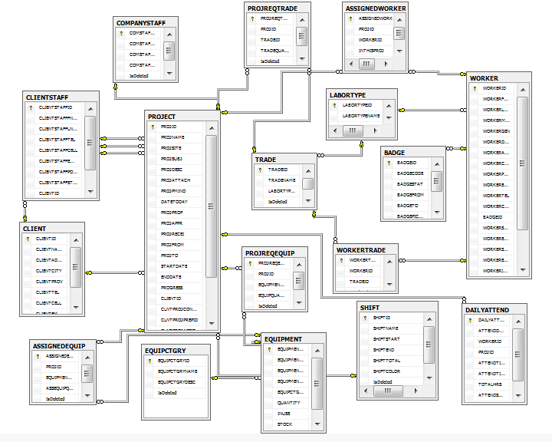**3.2.2.1 Database Schema**

**3.2.2.2 Data Dictionary**

|  |  |  |  |  |
| --- | --- | --- | --- | --- |
| Table Name : CLIENT  Table Description: Storage of the client’s information  Related Table: | | | | |
| ID | Column Name | Description | Data Type | Length |
| PK | CLIENTID | Identification of the client. | INT IDENTITY | 1,1 |
|  | CLIENTNAME | Name of the client | VARCHAR | 200 |
|  | CLIENTADDR | Address of the client | VARCHAR | 300 |
|  | CLIENTCITY | City of the client | VARCHAR | 100 |
|  | CLIENTPROV | Province of the client | VARCHAR | 100 |
|  | CLIENTTEL | Residential phone of the client | VARCHAR | 50 |
|  | CLIENTCELL | Mobile number used by client | VARCHAR | 50 |
|  | CLIENTEMAIL | Email Address of the client | VARCHAR | 100 |

Table 3.2.1 Client

|  |  |  |  |  |
| --- | --- | --- | --- | --- |
| Table Name : CLIENTSTAFF  Table Description: Project’s contact of the client  Related Table: CLIENT | | | | |
| ID | Column Name | Description | Data Type | Length |
| PK | CLIENTSTAFFID | Identification of the client contact | INT IDENTITY | 1,1 |
|  | CLIENTSTAFFFNAME | First name of the client contact in a project | VARCHAR | 200 |
|  | CLIENTSTAFFLNAME | Last name of the client contact in a project | VARCHAR | 50 |
|  | CLIENTSTAFFTE | Residential phone number of the client contact | VARCHAR | 50 |
|  | CLIENTSTAFFCELL | Mobile number of the client contact | VARCHAR | 50 |
|  | CLIENTSTAFFEMAIL | Email Address of the client contact | VARCHAR | 200 |
|  | CLIENTSTAFFPOSITION | Position of the client contact | VARCHAR | 200 |
|  | CLIENTSTAFFSTATUS | Whether the client contact is active or inactive | VARCHAR | 200 |
| Fk | CLIENTID | Identification of the client contact | INT | 20 |

Table 3.2.2 Client Staff

|  |  |  |  |  |
| --- | --- | --- | --- | --- |
| Table Name : EQUIPCTGRY  Table Description: Category of the equipment  Related Table: | | | | |
| ID | Column Name | Description | Data Type | Length |
| PK | EQUIPCTGRYID | Identification of the equipment’s category | INT IDENTITY | 1,1 |
|  | EQUIPCTGRYNAME | Category name of the equipment | VARCHAR | 200 |
|  | EQUIPCTGRYDESC | Description of the equipment’s category | VARCHAR | 200 |

Table 3.2.3 Equipment Category

|  |  |  |  |  |
| --- | --- | --- | --- | --- |
| Table Name : EQUIPMENT  Table Description: Storage of the equipment information  Related Table : EQUIPMENT_CATEGORY | | | | |
| ID | Column Name | Description | Data Type | Length |
| PK | EQUIPMENTID | Identification of the equipment | INT IDENTITY | 1,1 |
|  | EQUIPCTGRYID | Identification of the equipment category | INT |  |
|  | EQUIPMENTNAME | Name of the equipment | VARCHAR | 200 |
|  | EQUIPMENTDESC | Description of the equipment’s category | VARCHAR | 200 |
|  | QUANTITY | Total quantity of the equipment | VARCHAR | 50 |
|  | STOCK | Remaining quantity of the equipment | VARCHAR | 50 |
|  | INUSE | Quantity of equipment assigned | VARCHAR | 50 |
| Fk | EQUIPCTGRYID | Category of the equipment | INT |  |
|  | EQUIPMENTDESC | Description of the equipment | VARCHAR | 300 |

Table 3.2.4 Equipment

|  |  |  |  |  |
| --- | --- | --- | --- | --- |
| Table Name : PROJREQEQUIP  Table Description: Equipment assigned to a project  Related Table: PROJECT, EQUIPMENT | | | | |
| ID | Column Name | Description | Data Type | Length |
| PK | PROJREQEQUIPID | Identification of project equipments | INT IDENTITY | 1,1 |
|  | EQUIPQUANTITY | Total quantity of the equipment in the project | VARCHAR | 50 |
| Fk | PROJID | Identification of the project | INT |  |
| FK | EQUIPMENTID | Identification of the equipment | INT |  |

Table 3.2.5 Project Equipment

EQUIPMENTEquipment

|  |  |  |  |  |
| --- | --- | --- | --- | --- |
| Table Name : PROJECTATTEND  Table Description: Worker assigned to a project  Related Table: | | | | |
| ID | Column Name | Description | Data Type | Length |
| PK | PROJECTATTENDID | Identification of the equipment’s category | INT IDENTITY | 1,1 |
|  | DAILYATTENDI | Category name of the equipment | INT |  |
|  | PROJID | Description of the equipment’s category | INT |  |
|  | DAILYATTENDID | Identification of the equipment | INT |  |

Table 3.2.6 Project Attendance

|  |  |  |  |  |
| --- | --- | --- | --- | --- |
| Table Name : PROJECT  Table Description: Storage of Project Information  Related Table: CLIENT, COMPANYSTAFF, USER, | | | | |
| ID | Column Name | Description | Data Type | Length |
| PK | PROJID | Identification of the Project | INT IDENTITY | 1,1 |
|  | PROJNAME | Name of the Project | VARCHAR | 200 |
|  | PROJSITE | Location of the Project | VARCHAR | 300 |
|  | PROJSUBJ | Subject of the project | VARCHAR | 200 |
|  | PROJDESC | Description of the project | VARCHAR | 500 |
|  | PROJATTACH | Attachment file foe the project | VARCHAR | 300 |
|  | PROJPMINO | Project PMI number | VARCHAR | 200 |
|  | DATETODAY | Date today | DATE |  |
|  | PROJPROP | Date when the project was proposed | DATE | 10 |
|  | PROJAPPR | Date when the project was approved | DATE | 10 |
|  | PROJRECEI | Project Received | DATE |  |
|  | PROJFROM | Project from | DATE |  |
|  | PROJTO | Project to | DATE |  |
|  | STARTDATE | Date Started | DATE |  |
|  | ENDDATE | Date Ended | DATE |  |
|  | PROGRESS | Progress of the project | VARCHAR | 100 |
| Fk | CLIENTID | Identification of the client | INT |  |
| Fk | CLNTPROJCONTID | Identification of the client project | INT |  |
| Fk | CLNTPROJPREPID | Identification of client project prepared | INT |  |
| Fk | CLNTPROJAPPID | Identification of Client project Approved | INT |  |
| Fk | CNTRCTRPROJRECEIID | Identification of contractor project Received | INT |  |
| Fk | CNTRCTRPROJAPPID | Identification of contractor project Approved | INT |  |

Table 3.2.7 Project

|  |  |  |  |  |
| --- | --- | --- | --- | --- |
| Table Name : PROJREQTRADE  Table Description: Project Required Trade  Related Table: | | | | |
| ID | Column Name | Description | Data Type | Length |
| PK | PROJREQTRADEID | Identification of the project required tradetrade | INT IDENTITY | 1,1 |
| Fk | PROJID | Identification of the project | INT |  |
| Fk | TRADEID | Identificaton of trade | INT |  |
|  | TRADEQUANTITY | Trade quantity | VARCHAR | 50 |

Table 3.2.8 Project Trade

|  |  |  |  |  |
| --- | --- | --- | --- | --- |
| Table Name : PROJREQEQUIP  Table Description: Project Required Equipment  Related Table: | | | | |
| ID | Column Name | Description | Data Type | Length |
| PK | PROJREQEQUIPID | Identification of project required Equipment | INT IDENTITY | 1,1 |
| Fk | PROJID | Identification of the project | INT |  |
| Fk | EQUIPMENTID | Identification of equipment | INT |  |
|  | EQUIPQUANTITY | Equipment Quantity | VARCHAR | 50 |

Table 3.2.9 Project Equipment

|  |  |  |  |  |
| --- | --- | --- | --- | --- |
| Table Name : WORKER  Table Description: Storage of worker details  Related Table: WORKER_CATEGORY, WORKER_TRADE | | | | |
| ID | Column Name | Description | Data Type | Length |
| Pk | WORKERID | Identification of the worker | INT IDENTITY | 1,1 |
|  | WORKERFNAME | Worker’s First name | VARCHAR | 200 |
|  | WORKERLNAME | Worker’s Last name | VARCHAR | 200 |
|  | WORKERMIDNAME | Worker’s Middle name | VARCHAR | 200 |
|  | WORKERGEN | Worker’s Gender | VARCHAR | 50 |
|  | WORKERDOB | Worker’s date of birth | DATE |  |
|  | WORKERADDR | Worker’s Address | VARCHAR | 200 |
|  | WORKERCITY | Worker’s City | VARCHAR | 200 |
|  | WORKERPROV | Worker’s Province | VARCHAR | 200 |
|  | WORKEREMAIL | Worker’s Email | VARCHAR | 200 |
|  | WORKERTEL | Residential phone number of the worker | VARCHAR | 50 |
|  | WORKERCELL | Cellphone Number of the worker | VARCHAR | 50 |
|  | BADGEID | Worker’s Badge No. | INT |  |
|  | WORKERSTARTDATE | Worker’s Date Started | DATE |  |
|  | WORKERENDDATE | Worker’s Date Ended | DATE |  |
|  | WORKERSTATUS | Status of the Worker | VARCHAR | 200 |
|  | WORKEREMPLOYTYPE | Worker’s Employee Type | VARCHAR | 200 |
|  | WORKERIMAGE | Image of the worker | VARCHAR | 300 |
|  | ASSWORKER | Worker’s Assign | BIT |  |
| Fk | LABORTYPEID | Worker’s LabortypeID | INT |  |

Table 3.2.10 Worker

|  |  |  |  |  |
| --- | --- | --- | --- | --- |
| Table Name : Worker Trade  Table Description: Trade of the Worker  Related Table: | | | | |
| ID | Column Name | Description | Data Type | Length |
| PK | WORKERTRADEID | Identification of the worker trade | INT IDENTITY | 1,1 |
| Fk | WORKERID | Identification of worker | INT |  |
| Fk | TRADEID | Trade identification | INT |  |

Table 3.2.11 Worker Trade

|  |  |  |  |  |
| --- | --- | --- | --- | --- |
| Table Name : ASSIGNEDWORKER  Table Description: Worker assigned to a project  Related Table: | | | | |
| ID | Column Name | Description | Data Type | Length |
| PK | ASSIGNEDWORKERID | Identification of the equipment’s category | INT IDENTITY | 1,1 |
|  | PROJID | Category name of the equipment | INT |  |
|  | WORKERID | Description of the equipment’s category | INT |  |
|  | INTHISPROJ | Whether the worker is active or inactive | BIT |  |
| Fk | PROJID | Category name of the equipment | INT |  |
|  | EQUIPMENTID | Identification of the equipment | INT |  |

Table 3.2.12 Assigned Worker

|  |  |  |  |  |
| --- | --- | --- | --- | --- |
| Table Name : ASSIGNEDEQUIP  Table Description: Project Required Trade  Related Table: | | | | |
| ID | Column Name | Description | Data Type | Length |
| PK | ASSIGNEDEQUIPID | Identification of Assign Equipment | INT IDENTITY | 1,1 |
| Fk | PROJID | Identification of the project | INT |  |
| Fk | EQUIPMENTID | Identification of equipment | INT |  |
|  | ASSEQUIPQUANT | Assign Equipment Quantity | VARCHAR | 50 |

Table 3.2.13 Assigned Equipment

|  |  |  |  |  |
| --- | --- | --- | --- | --- |
| Table Name : SHIFT  Table Description:  Related Table: | | | | |
| ID | Column Name | Description | Data Type | Length |
| PK | SHIFTID | Identification of Shift | INT IDENTITY | 1,1 |
|  | SHIFTNAME | Name of Shift | VARCHAR | 200 |
|  | SHIFTSTART | Start of Shift | DATETIME |  |
|  | SHIFTEND | End of Shift | DATETIME |  |
|  | SHIFTTOTAL | Total Of Shift | VARCHAR | 200 |
|  | SHIFTCOLOR | Color of the Shift | VARCHAR | 200 |

Table 3.2.14 Shift

|  |  |  |  |  |
| --- | --- | --- | --- | --- |
| Table Name : Badge  Table Description: Badge Number of the Worker  Related Table: | | | | |
| ID | Column Name | Description | Data Type | Length |
| PK | BADGEID | Badge Id | INT IDENTITY | 1,1 |
|  | BADGECODE | Badge Code | VARCHAR | 200 |
|  | BADGESTAT | Badge Status | VARCHAR | 200 |
|  | BADGEFROM | Badge From | DATE |  |
|  | BADGETO | Badge To | DATE |  |
|  | BADGEPICCODE | Badge Picture Code | VARCHAR | 300 |
| Fk | WORKERID | Identification of the Worker | INT |  |

Table 3.2.15 Badge

|  |  |  |  |  |
| --- | --- | --- | --- | --- |
| Table Name : DAILYATTEND  Table Description: Daily Attendance  Related Table: | | | | |
| ID | Column Name | Description | Data Type | Length |
| PK | DAILYATTENDID | Identification of daily Attendance | INT IDENTITY | 1,1 |
|  | ATTENDDDATE | Date of attendance | DATE |  |
|  | WORKERID | Identification of the worker | INT |  |
|  | PROJID | Identification of project | INT |  |
|  | ATTENDTIMEIN | Attendance Time-In | DATETIME |  |
|  | ATTENDTIMEOUT | Attendance Time-Out | DATETIME |  |
|  | TOTALHRS | Total Hours | VARCHAR | 20 |

Table 3.2.16 Daily Attendance

|  |  |  |  |  |
| --- | --- | --- | --- | --- |
| Table Name : Trade  Table Description: Skills or trade of worker  Related Table: | | | | |
| ID | Column Name | Description | Data Type | Length |
| PK | TRADEID | Identification of the Trade | INT IDENTITY | 1,1 |
|  | TRADENAME | Name of the trade | VARCHAR | 200 |
| Fk | LABORTYPEID | Identification of the type of labor | INT |  |

Table 3.2.17 Trade

**3.2.3 Screen Design**

**3.2.3.1 Screen Inventory**

|  |  |  |
| --- | --- | --- |
| # | Name | Description |
| 1 | Log-in Form | Allow the user to log-in and access the system |
| 2 | Dashboard Form | The home page and the main interface of the system. |
| 3 | Worker Form | Allows the user to manage workers information in the system. |
| 4 | Equipment Form | Allows the user to manage the equipment information in the system |
| 5 | Project Form | Allows the user to manage a project that has been entered in the system |
| 6 | Attendance Form | This allows the user to manage the attendance file generated by the system. |
| 7 | Client Form | Allows the user to add, delete and modify the client information |
| 8 | Maintenance Form | Allows the user to add, edit and delete of records in maintenance. |

**Table 3.2.2 Screen Inventory**

**3.2.3.2 Screen Layout**



**Home Page**

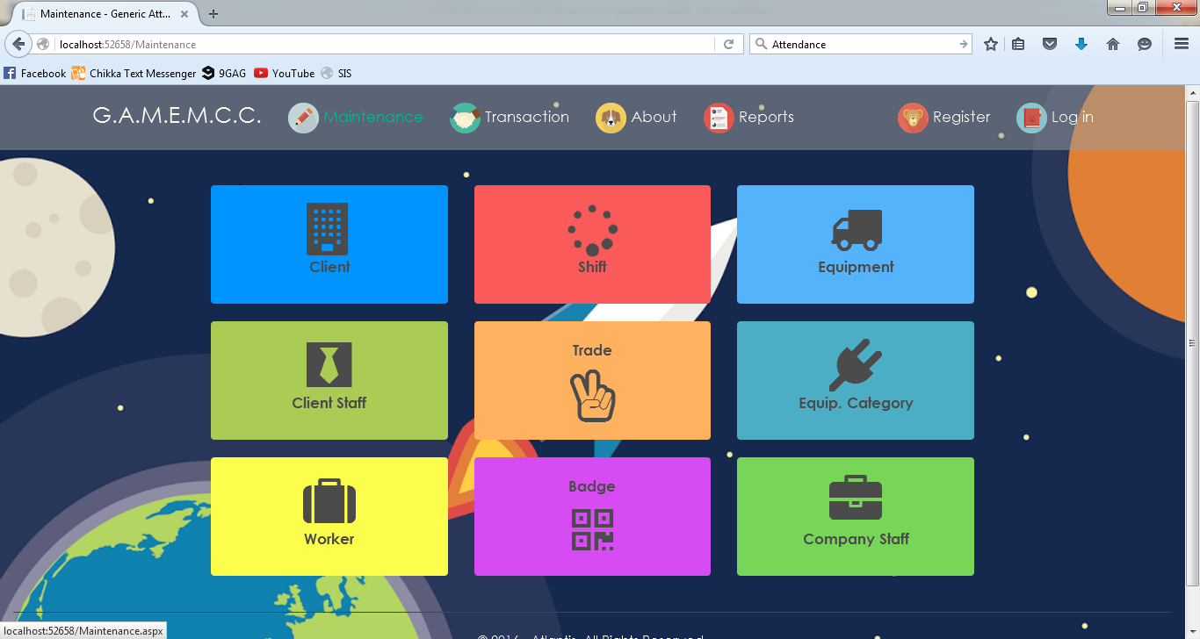

**Maintenance**

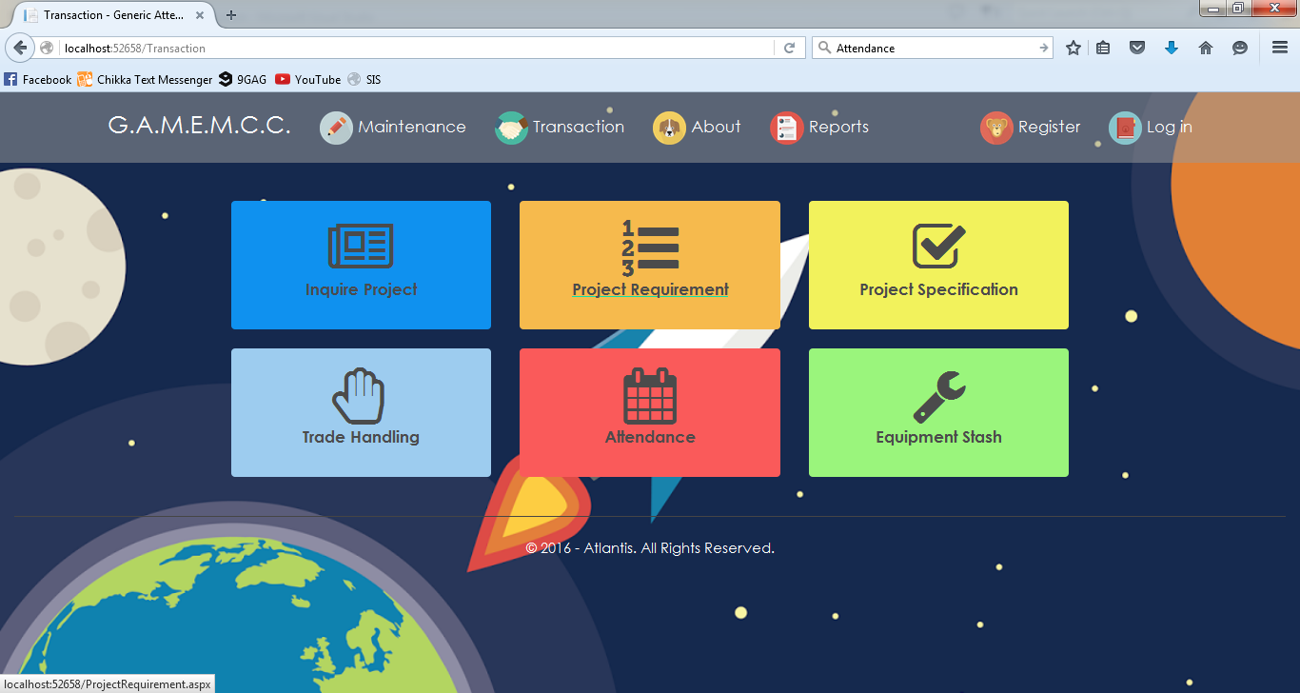

**Transaction**

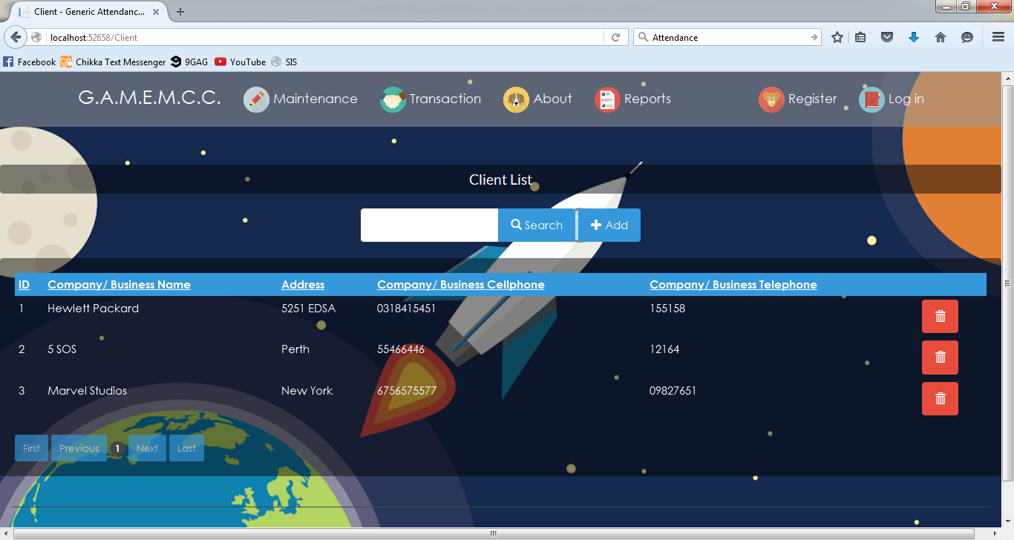

**Client List**

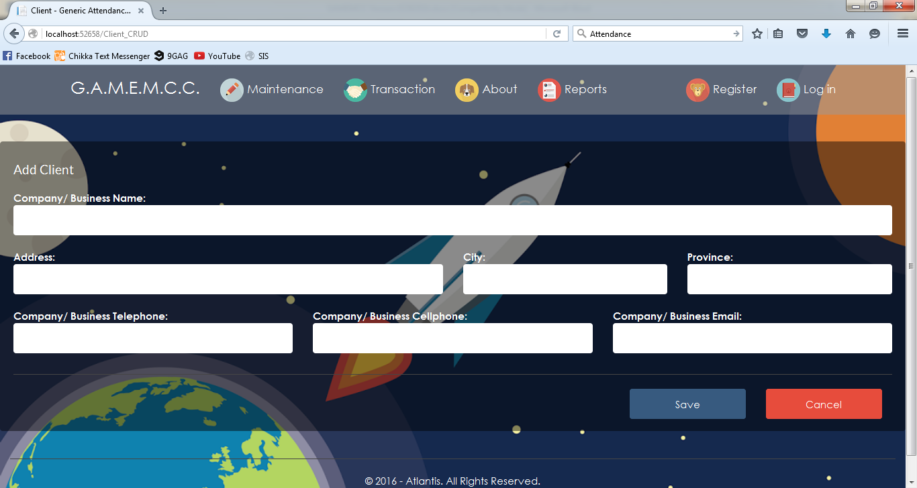

**Add Client**

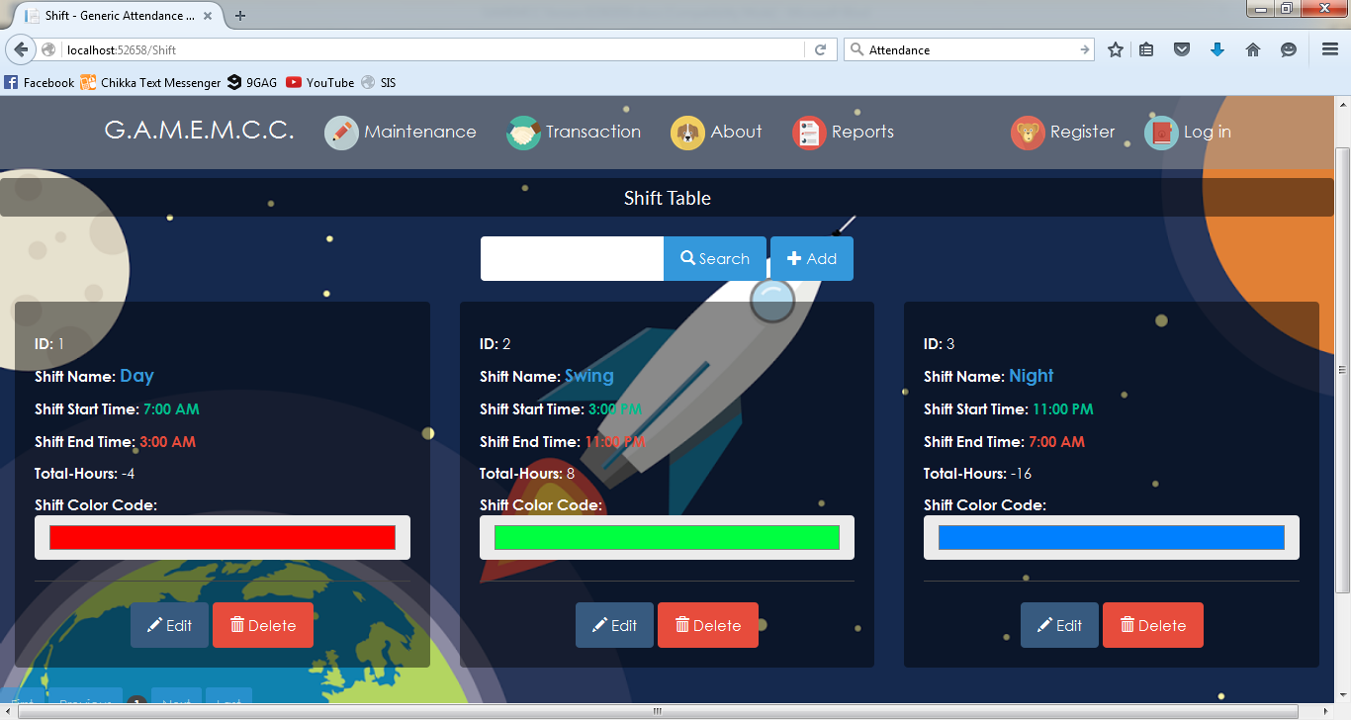

**Shift Table**

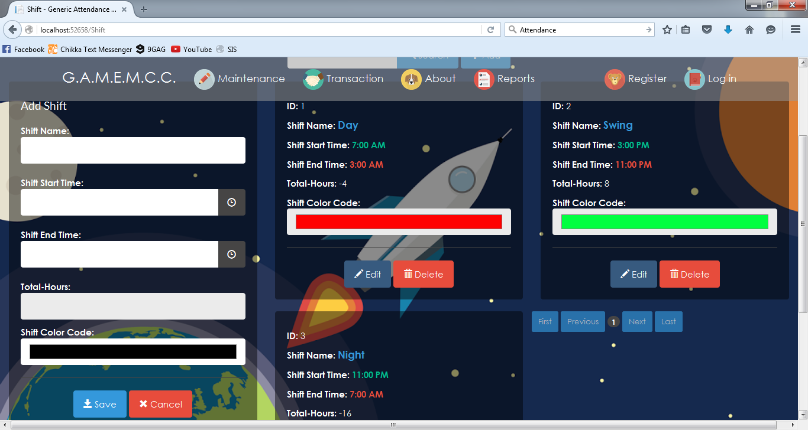

**Add Shift**

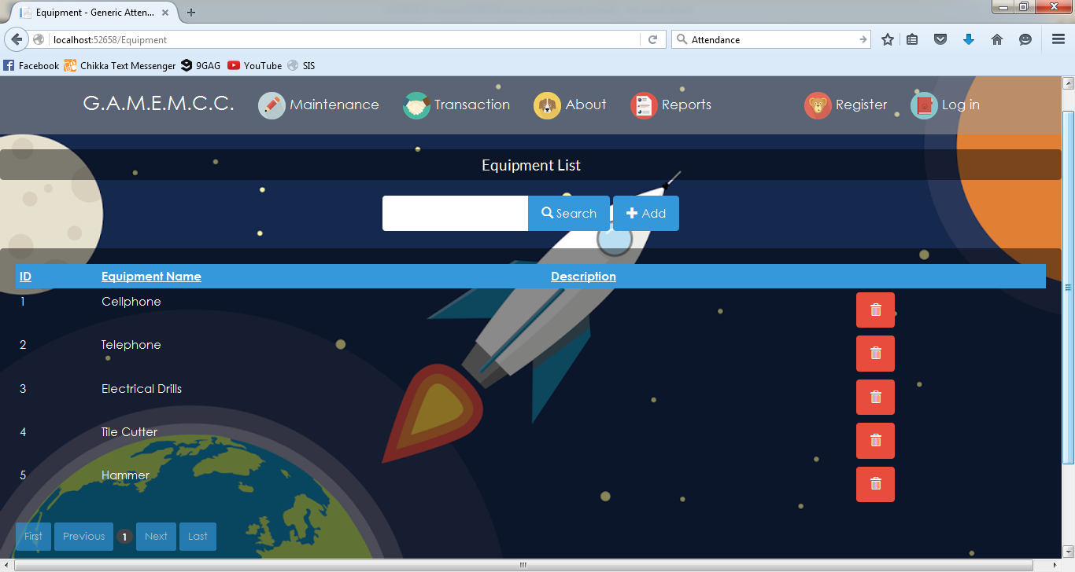

**Equipment List**

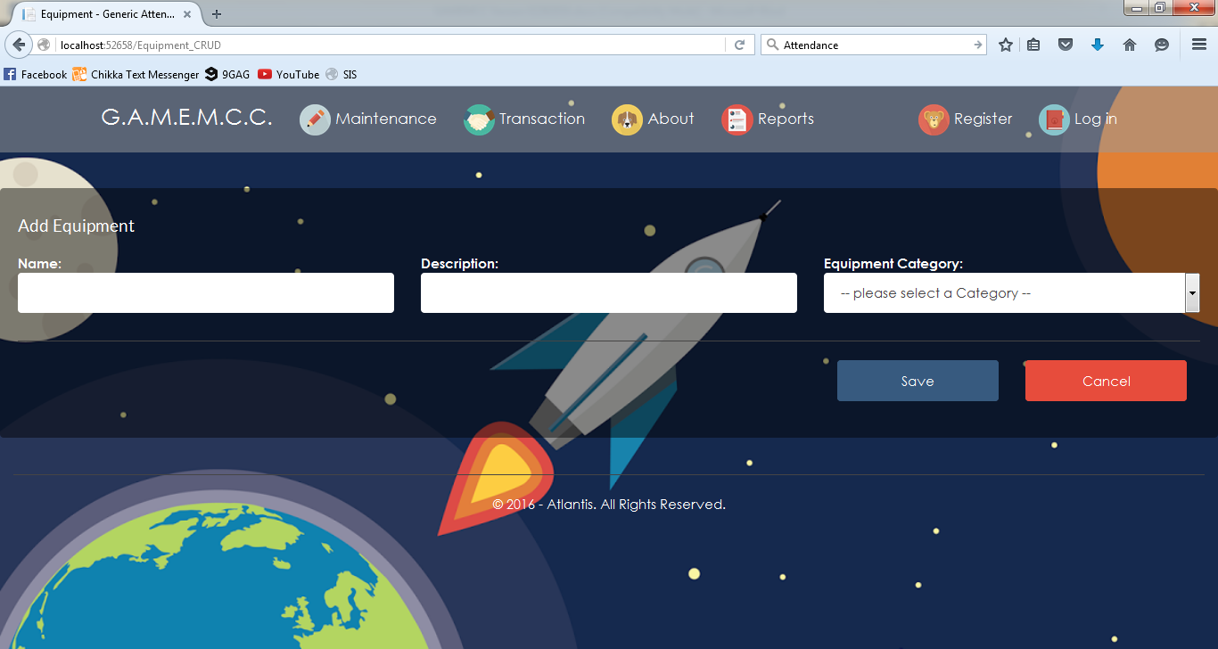

**Add Equipment**

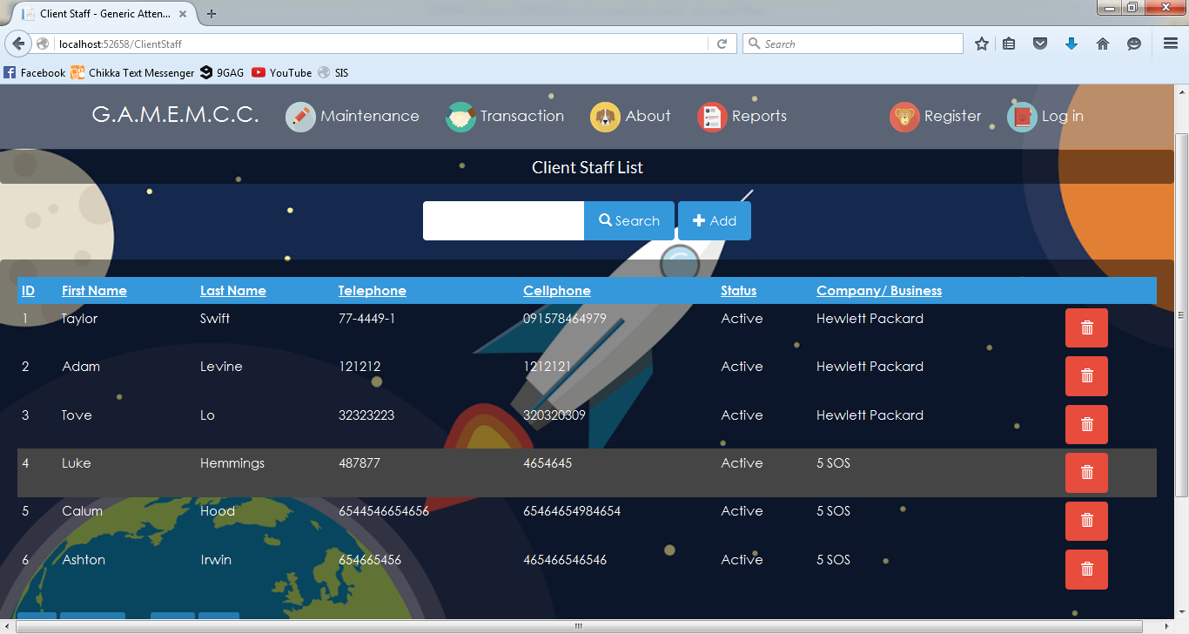

**Client Staff List**

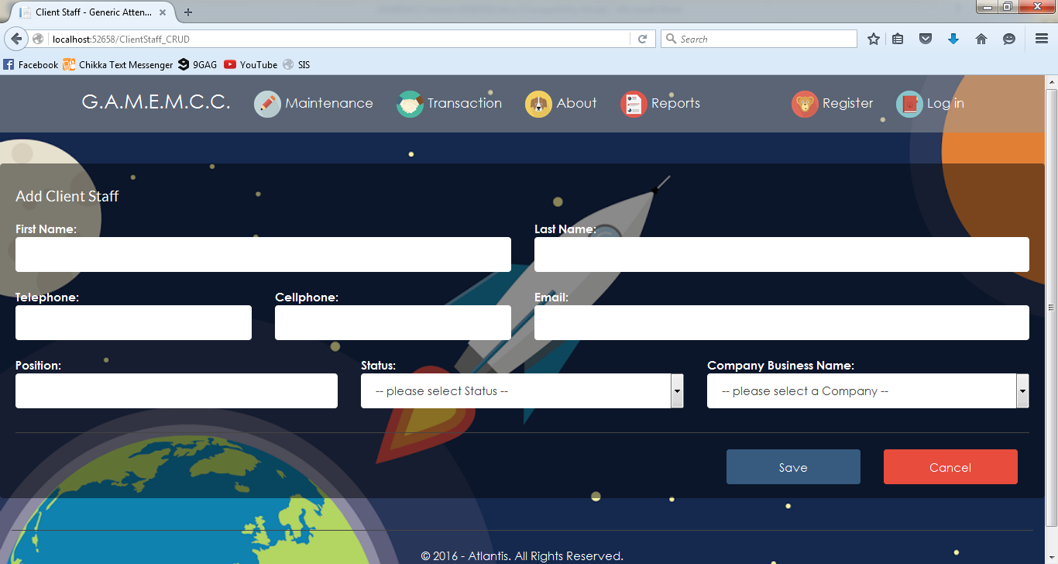

**Add Client Staff**

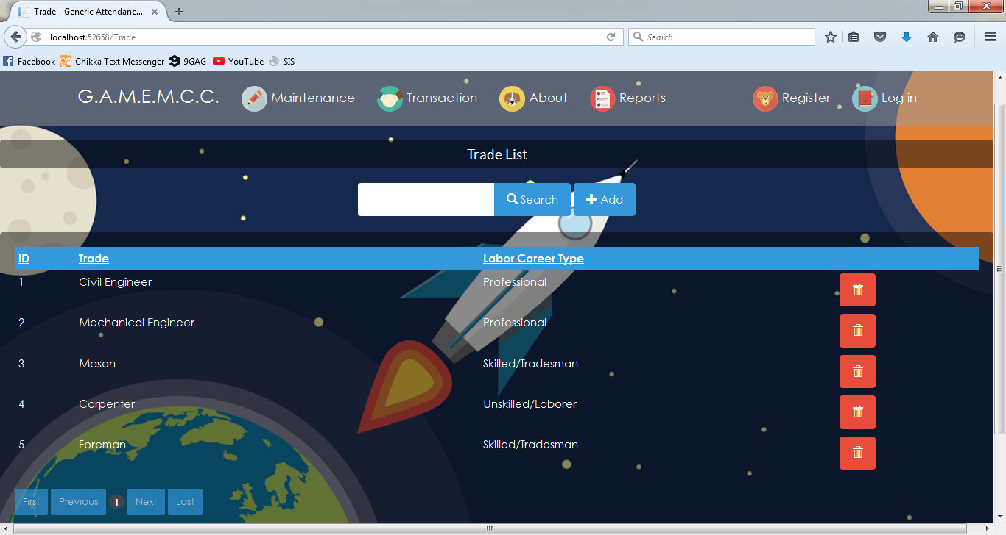

**Trade List**

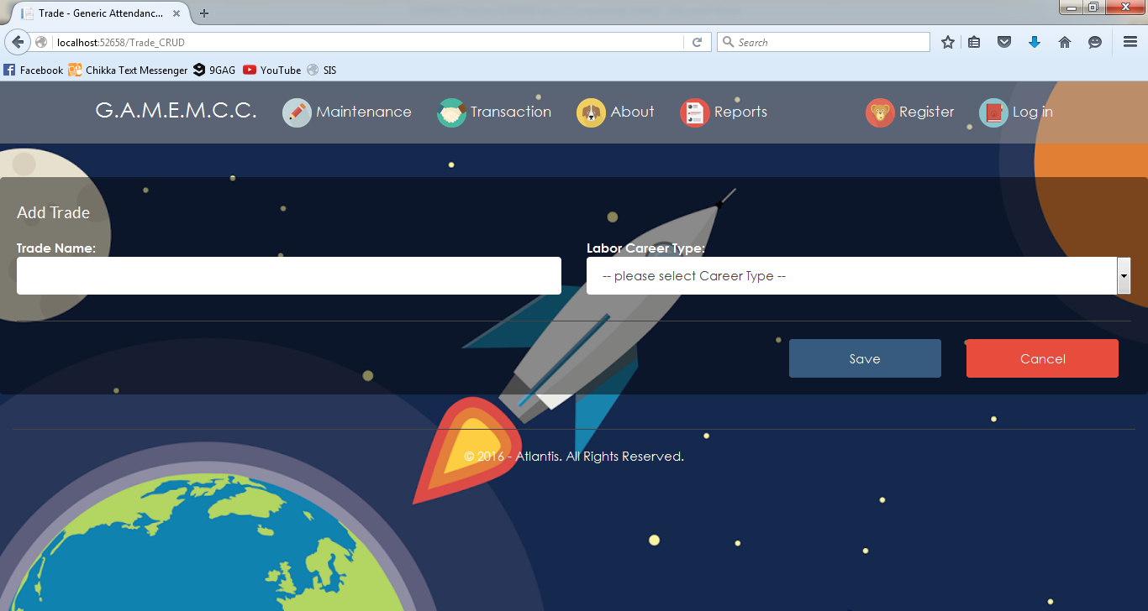

**Add Trade**

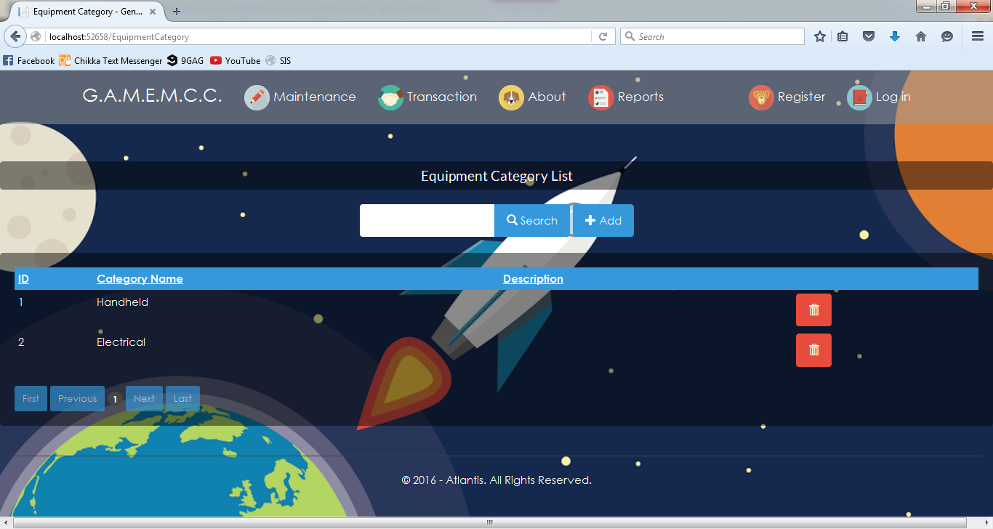

**Equipment Category List**

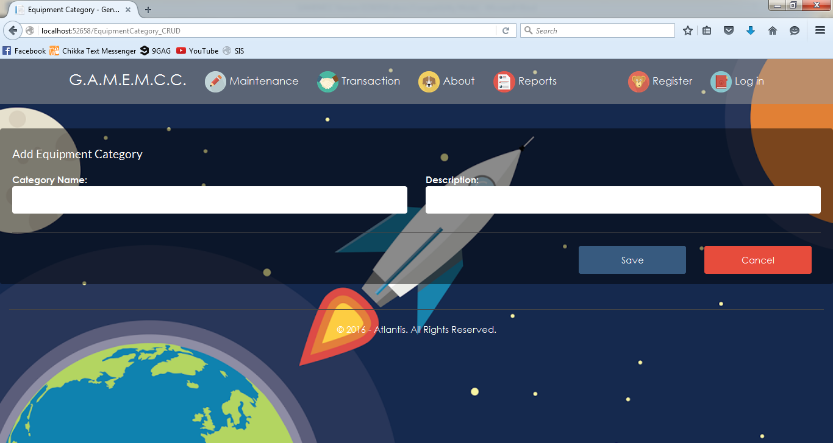

**Add Equipment Category**

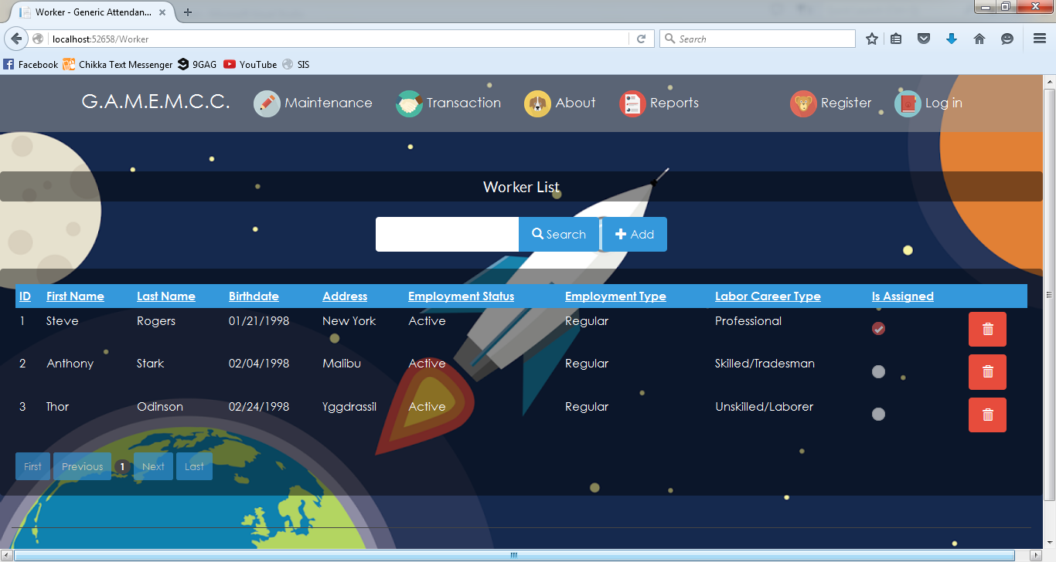

**Worker List**

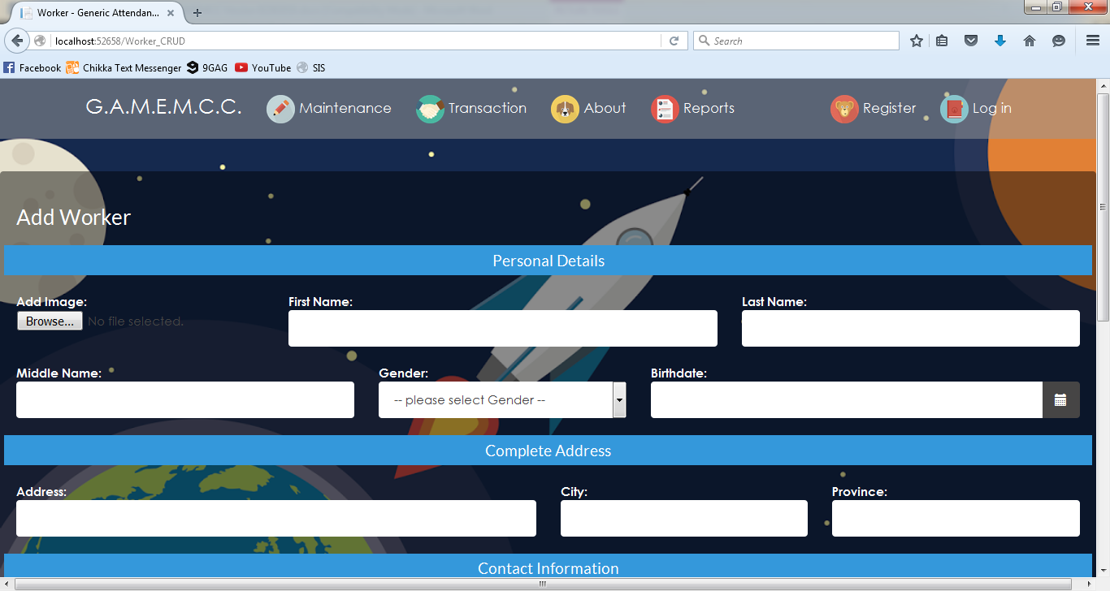

**Add Worker**

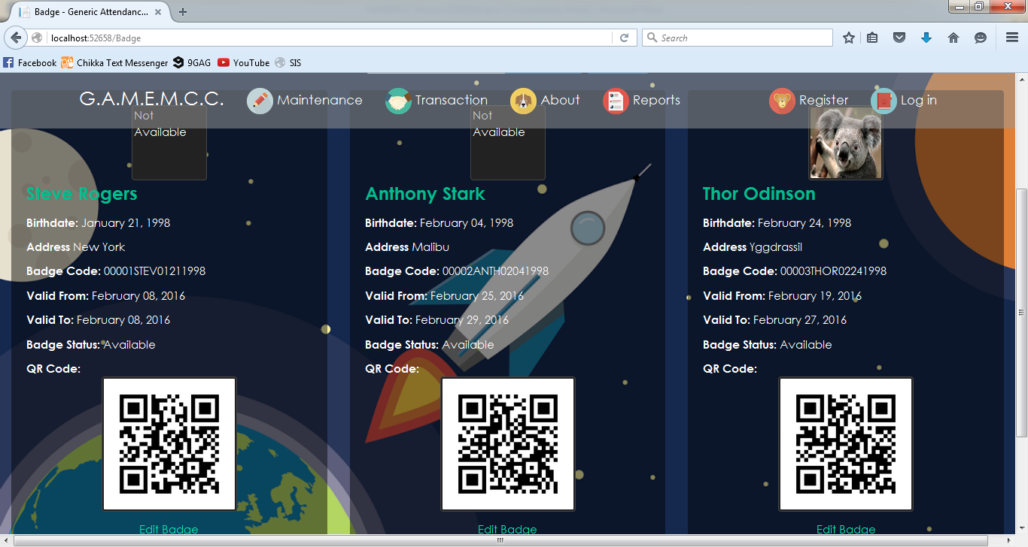

**Badges**

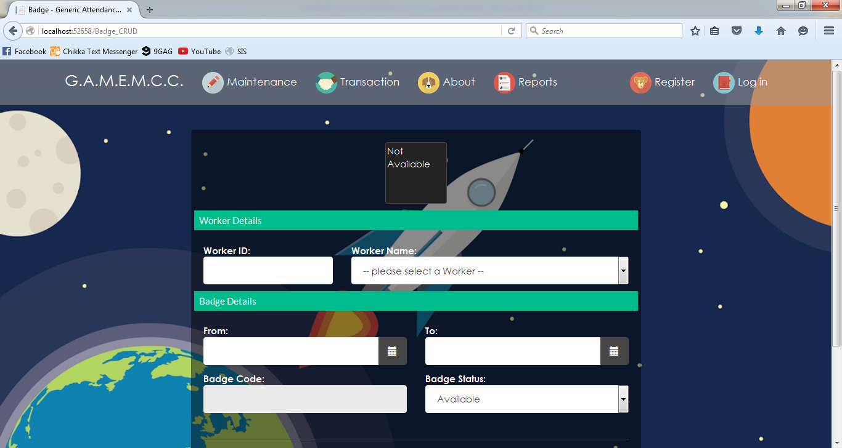

**Add Badge**

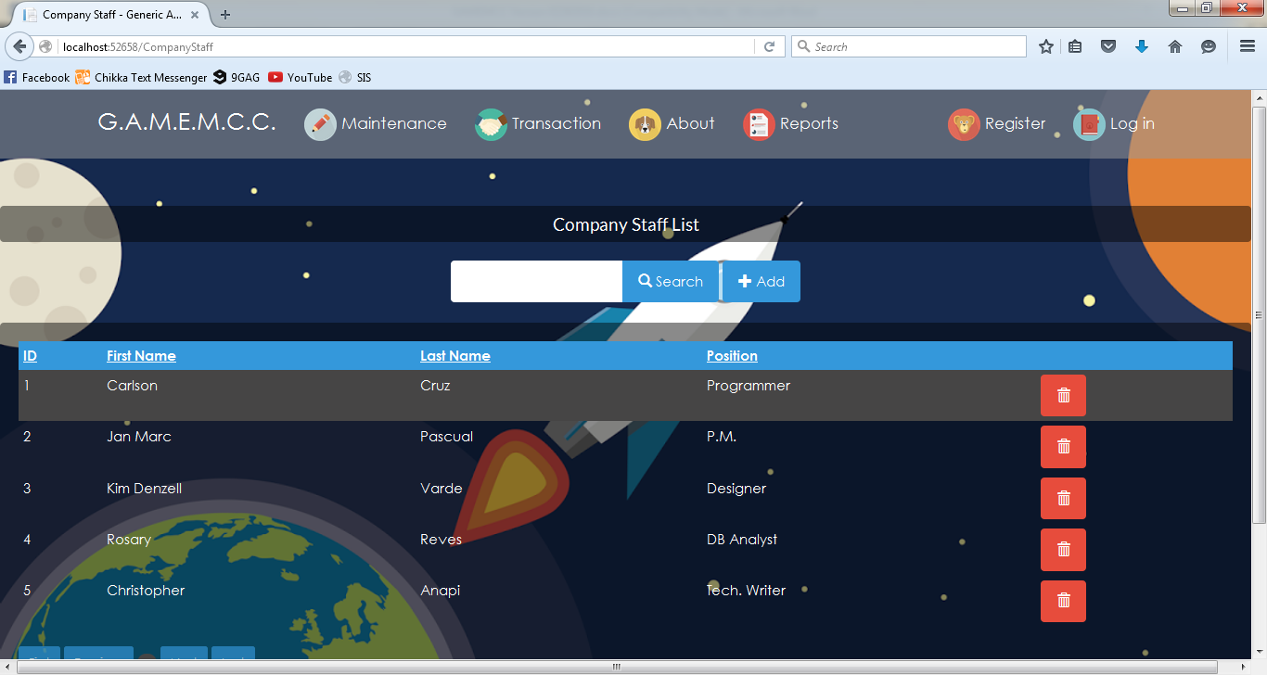

**Company Staff List**

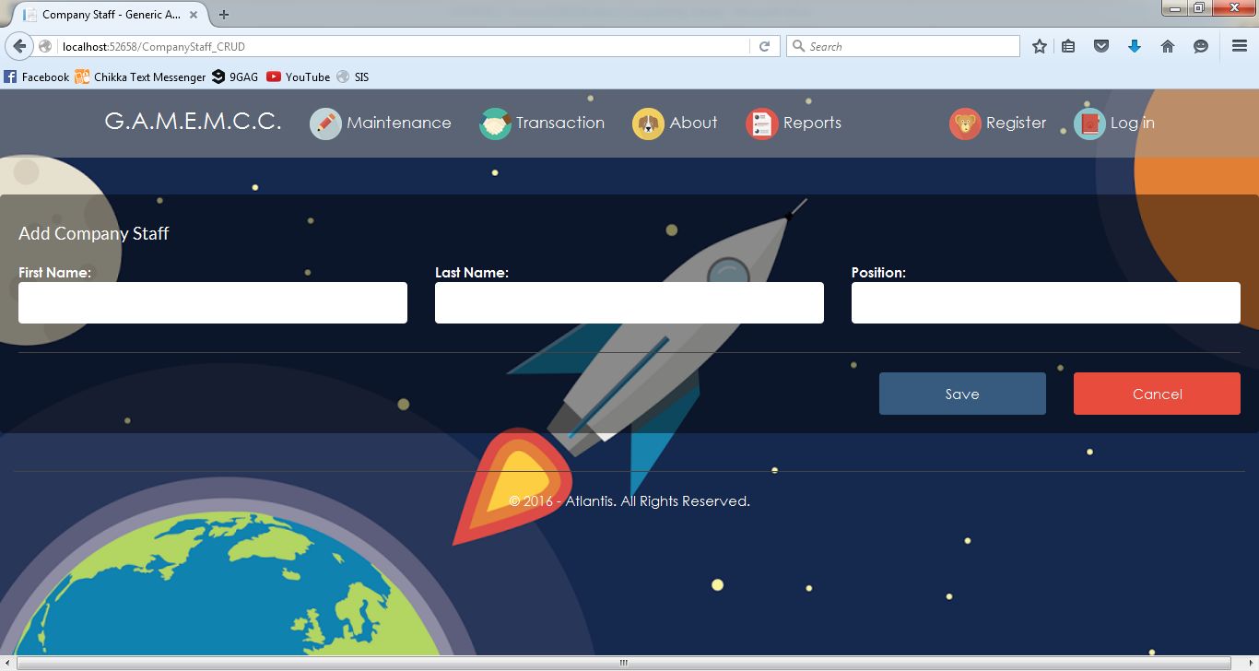

**Add Company Staff**

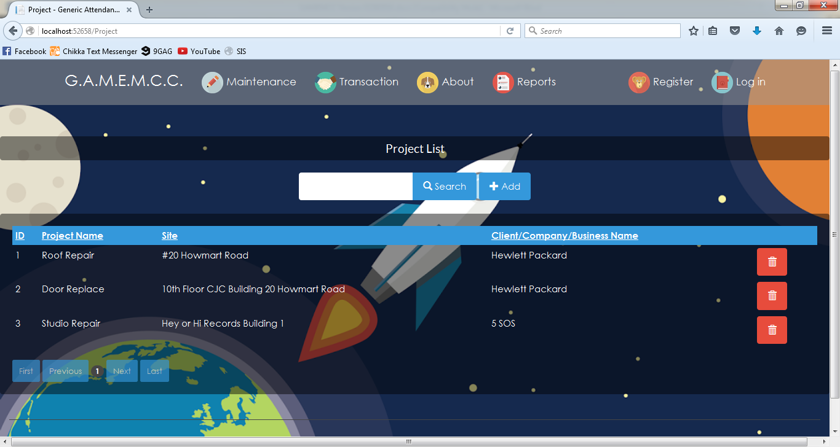

**Project List**

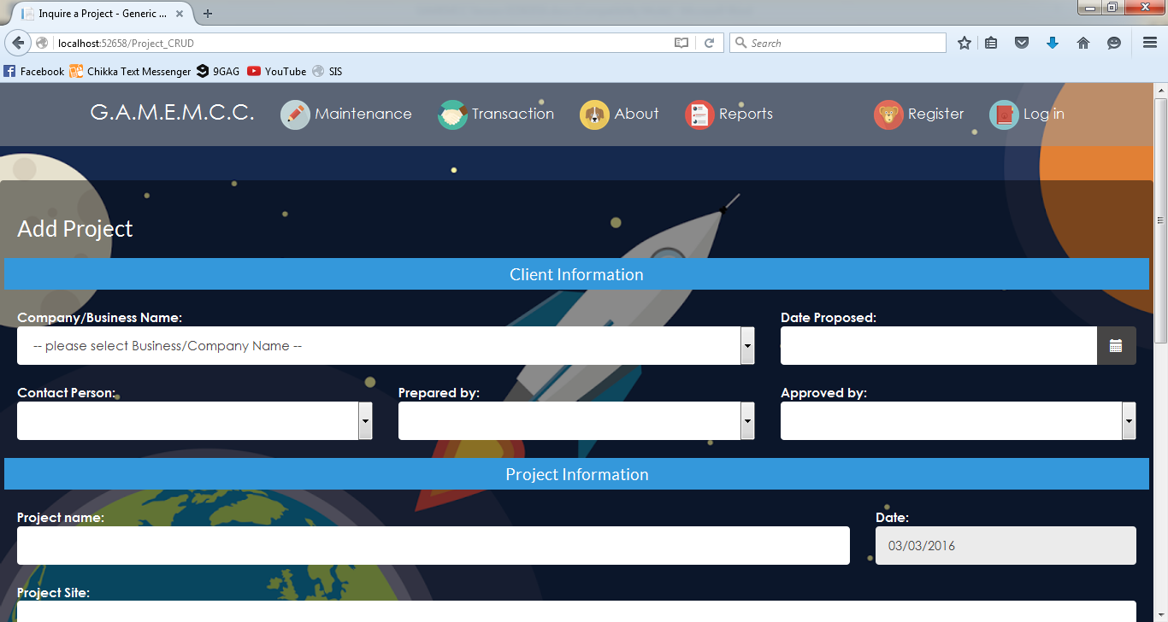

**Add Project**

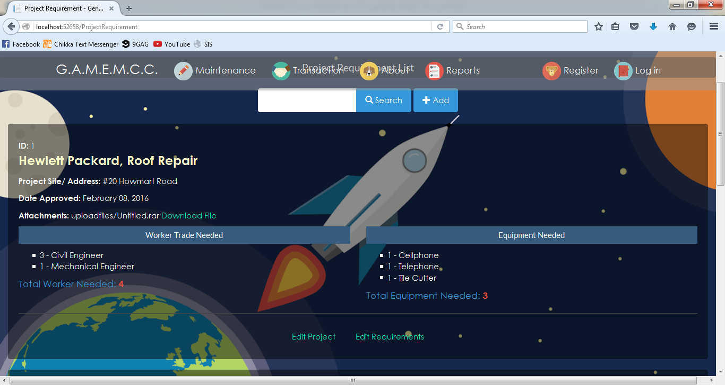

**Project Requirement List**

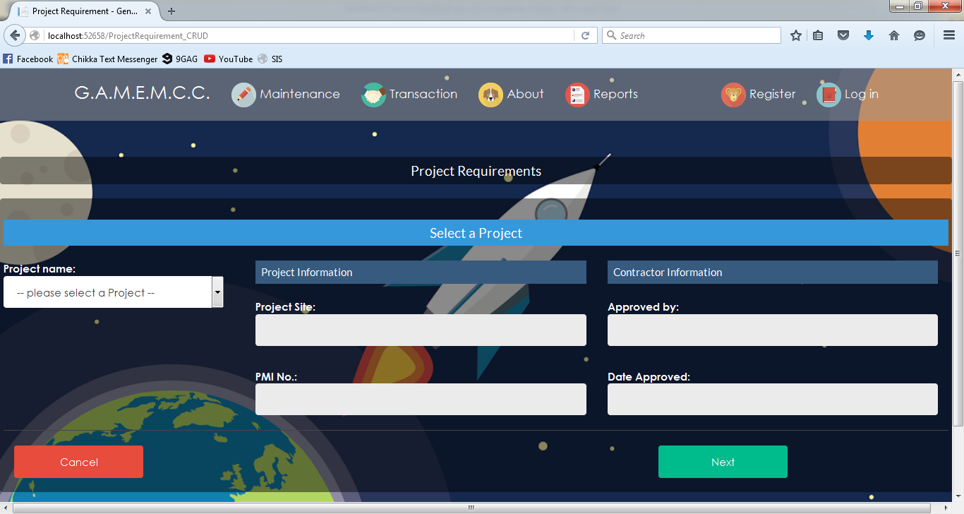

**Add Project Requirements**

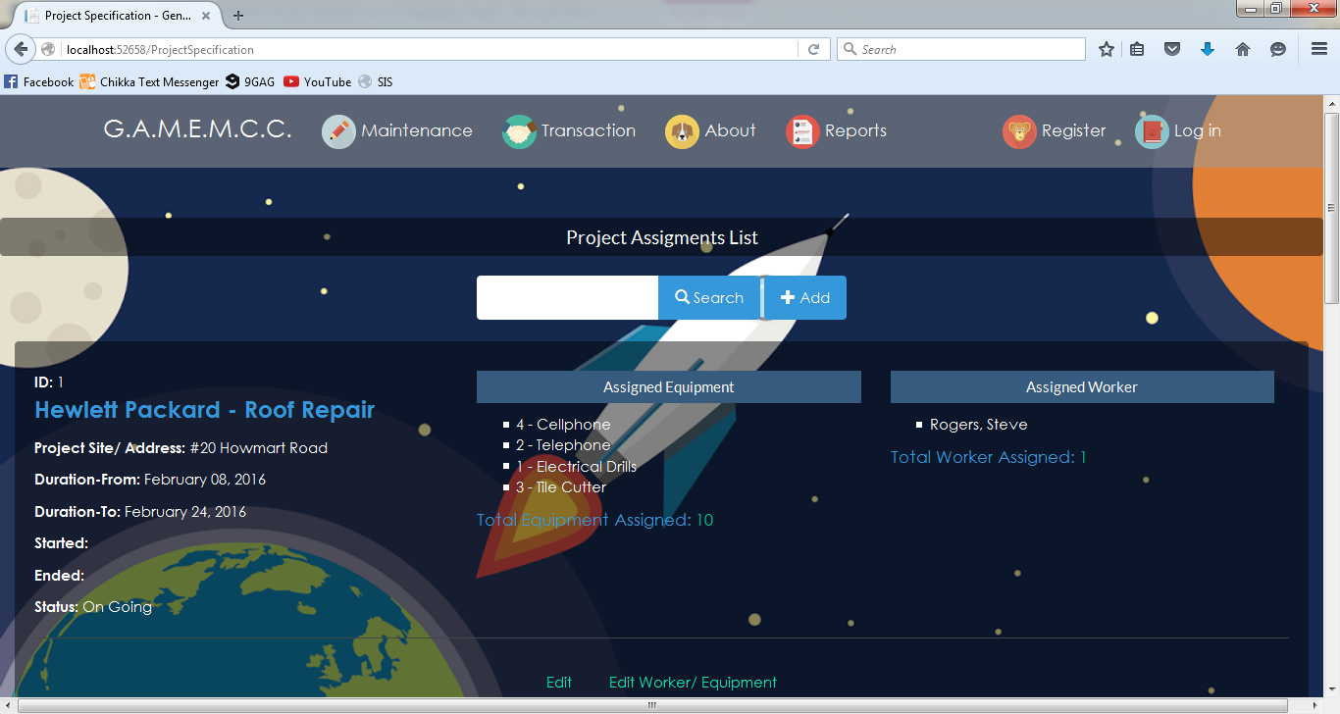

**Project Assignment List**

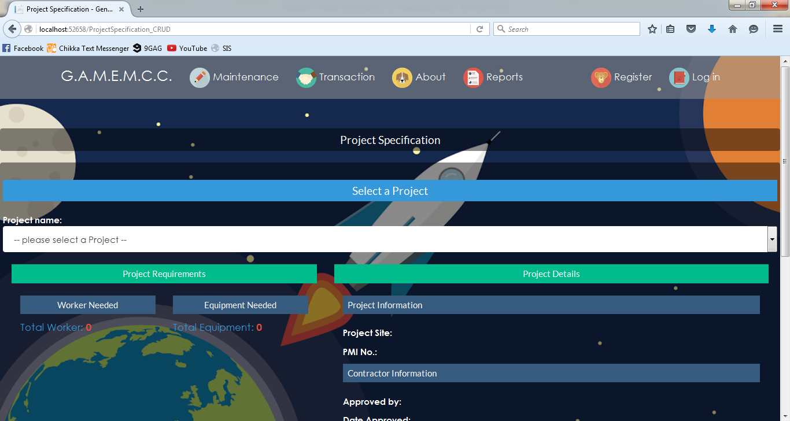

**Project Specification**

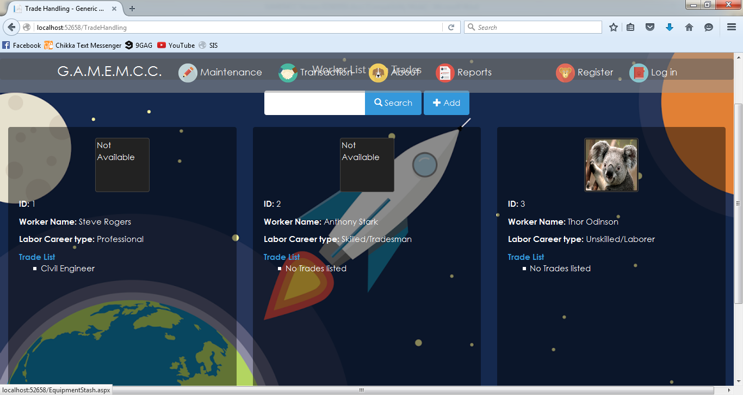

**Worker List with Trades**

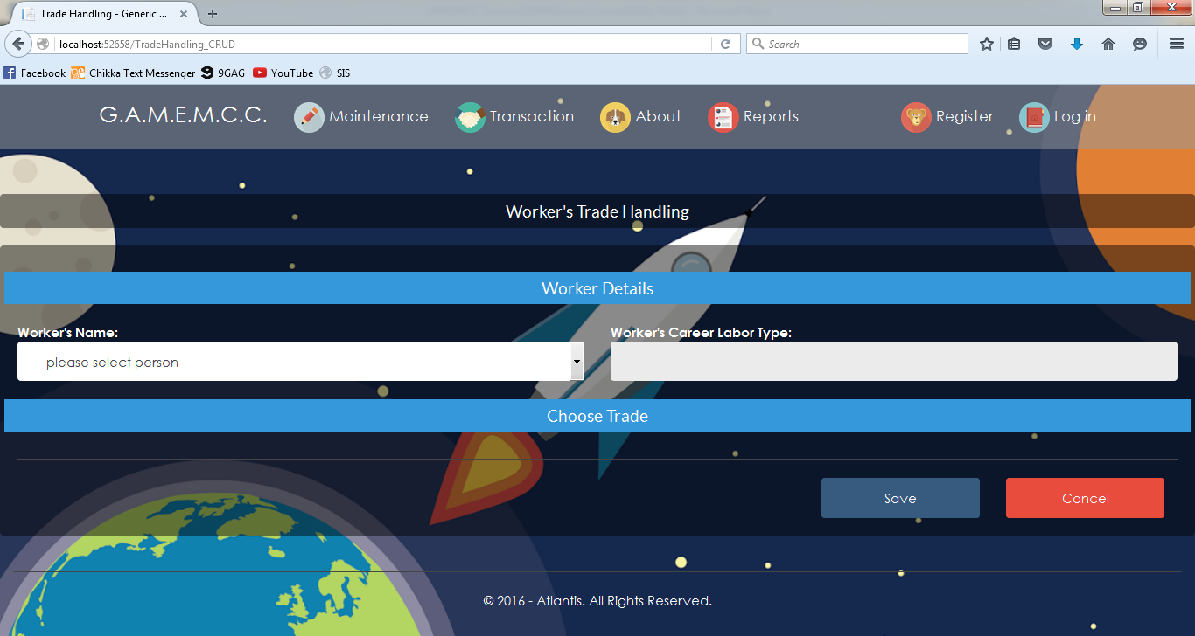

**Worker’s Trade Handling**



**Attendance Menu**

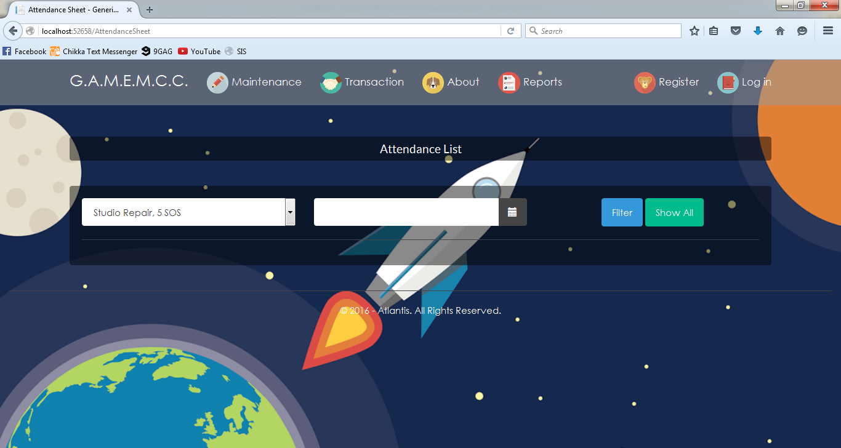

**Attendance List**

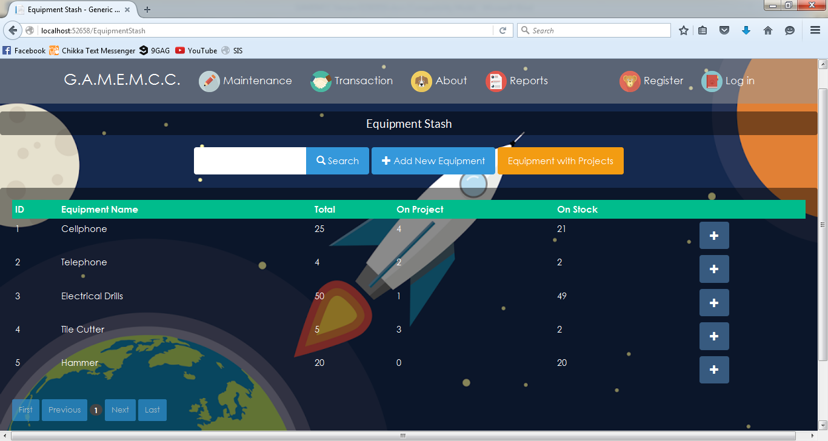

**Equipment Stash**

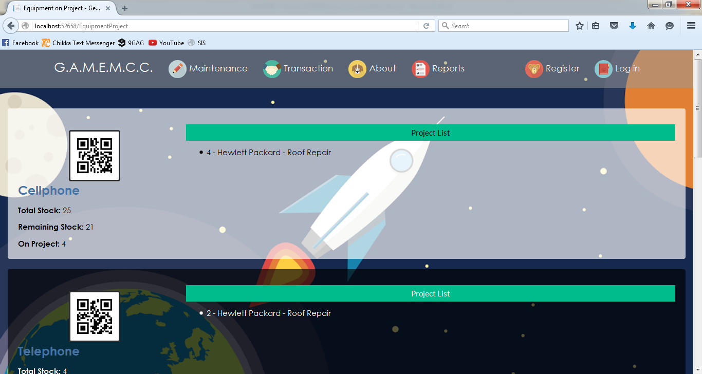

**Equipment in Project**

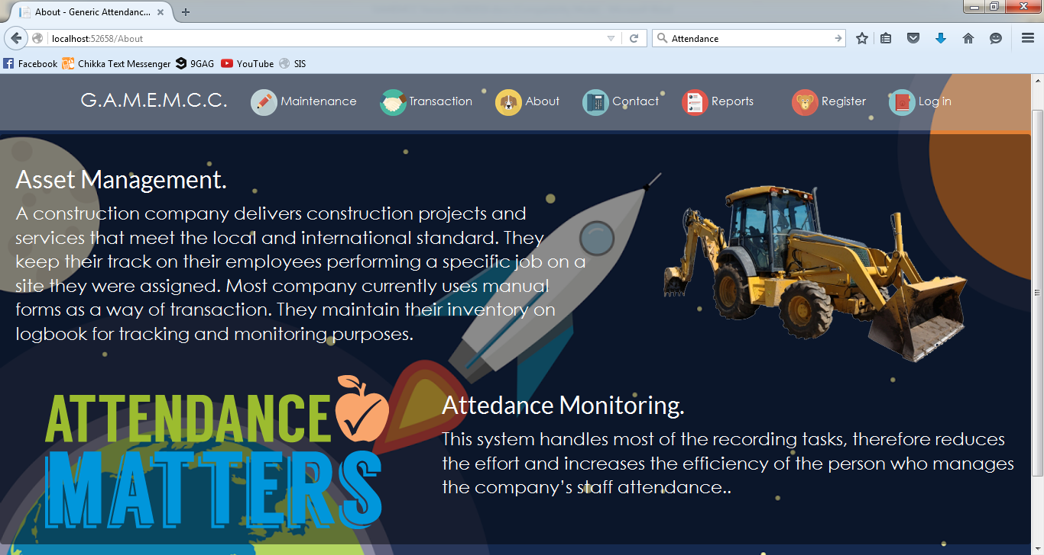

**About**

**Jan Marc A. Pascual**

**Address No:** Lot 10 Blk 16 Dollar St. Greenpark Cainta Village Cainta, Rizal

**Contact No:** 09253673648

**Email address:** janmarcpascual@gmail.com

**Skills**

* Knowledge at Microsoft Office: 2007, 2010, 2013
* Knowledgeable in Technical Writing
* Proficient in programming languages such as Visual Basic .NET.
* Advance knowledge and editing skills in Adobe Photoshop, and Flash
* Knowledgeable in CISCO Packet Tracer
* Advance knowledge on website development: HTML, CSS, Bootstrap, JavaScript and ASP.NET
* Knowledgeable on Database Administration Tools: SQL Server and Microsoft Access
* Computer Assembling and Maintenance
* Troubleshooting of hardware and software problems
* Installing and configuring peripherals, components and drivers
* Installing software and application to user standards

**Personal Information:**

**Height:** 5’6 ft.

**Weight:** 65 kg

**Sex:** Male

**Date of Birth:** February 10, 1996

**Civil Status:** Single

**Nationality:** Filipino

**Religion:** Roman Catholic

**EDUCATIONAL BACKGROUND**

**PRIMARY:** Lightbearer Christian Academy (2002-2008)

**SECONDARY:** National College of Business and Arts (2008-2012)

**TERTIARY:** Polytechnic University of the Philippines (2012-Present)

|  |
| --- |
| **Trainings and Seminars**   * CCIS @29: THE JOURNEY TO SUCCESS 2015- PUP MANILA   + Discussed the topic UX Design and Web Trends * 3rd UNIVERSITY – WIDE IT RESEARCH FORUM 2015 IN PUP MANILA   + The forum discussed different methods in researching and introduced different researches in the field of Information Technology. |

**Christopher G. Anapi**

**Address No:** 09 Banag Balucuc, Apalit, Pampanga

**Contact No:** 09068784737

**Email address:** anaps.chris@gmail.com

|  |
| --- |
|  |

**Skills**

* Knowledge at Microsoft Office: 2007, 2010, 2013
* Knowledgeable in Technical Writing
* Proficient in programming languages such as Visual Basic .NET.
* Advance knowledge and editing skills in Adobe Photoshop, and Flash
* Knowledgeable in CISCO Packet Tracer
* Knowledgeable on Database Administration Tools: SQL Server and Microsoft Access
* Computer Assembling and Maintenance
* Troubleshooting of hardware and software problems
* Installing and configuring peripherals, components and drivers
* Installing software and application to user standards

**Personal Information:**

**Height:** 5’7 ft.

**Weight:** 65 kg

**Sex:** Male

**Date of Birth:** April 3, 1996

**Civil Status:** Single

**Nationality:** Filipino

**Religion:** Roman Catholic

**EDUCATIONAL BACKGROUND**

**PRIMARY:** Banag Elementary School (2002-2008)

**SECONDARY:** Balucuc High School (2008-2012)

**TERTIARY:** Polytechnic University of the Philippines (2012-Present)

|  |
| --- |
| **Trainings and Seminars**   * CCIS @29: THE JOURNEY TO SUCCESS 2015- PUP MANILA   + Discussed the topic UX Design and Web Trends * 3rd UNIVERSITY – WIDE IT RESEARCH FORUM 2015 IN PUP MANILA   + The forum discussed different methods in researching and introduced different researches in the field of Information Technology. |

**Kim Denzel Varde**

**Address No:** 179 Zanboanga St. Bagong Barrio Caloocan City

**Contact No:** 09159735915

**Email address:** kdenzellvarde@yahoo.com

|  |
| --- |
|  |

**Skills**

* Knowledge at Microsoft Office: 2007, 2010, 2013
* Knowledgeable in Technical Writing
* Proficient in programming languages such as Visual Basic .NET.
* Advance knowledge and editing skills in Adobe Photoshop, and Flash
* Knowledgeable in CISCO Packet Tracer
* Knowledgeable on Database Administration Tools: SQL Server and Microsoft Access
* Computer Assembling and Maintenance
* Troubleshooting of hardware and software problems
* Installing and configuring peripherals, components and drivers
* Installing software and application to user standards

**Personal Information:**

**Height:** 5’4 ft.

**Weight:** 57 kg

**Sex:** Male

**Date of Birth:** November 9. 1995

**Civil Status:** Single

**Nationality:** Filipino

**Religion:** Roman Catholic

**EDUCATIONAL BACKGROUND**

**PRIMARY:** Bagong barrio elementary School (2002-2008)

**SECONDARY:** St. Vincent School Foundation Paniqui, Tarlac (2008-2012)

**TERTIARY:** Polytechnic University of the Philippines (2012-Present)

|  |
| --- |
| **Trainings and Seminars**   * CCIS @29: THE JOURNEY TO SUCCESS 2015- PUP MANILA   + Discussed the topic UX Design and Web Trends * 3rd UNIVERSITY – WIDE IT RESEARCH FORUM 2015 IN PUP MANILA   + The forum discussed different methods in researching and introduced different researches in the field of Information Technology. |

**Carlson Cruz**

**Address No:** #20 Howmart Road Brgy. Apolonio Samson

**Contact No:** 09169118616

**Email address:** carl_son_cruz@live.com

|  |
| --- |
|  |

**Skills**

* Knowledge at Microsoft Office: 2007, 2010, 2013
* Knowledgeable in Technical Writing
* Proficient in programming languages such as Visual Basic .NET.
* Advance knowledge and editing skills in Adobe Photoshop, and Flash
* Knowledgeable in CISCO Packet Tracer
* Knowledgeable on Database Administration Tools: SQL Server and Microsoft Access
* Computer Assembling and Maintenance
* Troubleshooting of hardware and software problems
* Installing and configuring peripherals, components and drivers
* Installing software and application to user standards

**Personal Information:**

**Height:** 5’1 ft.

**Weight:** 35 kg

**Sex:** Male

**Date of Birth:** October 18, 1994

**Civil Status:** Single

**Nationality:** Filipino

**Religion:** Roman Catholic

**EDUCATIONAL BACKGROUND**

**PRIMARY:** San Antonio Elementary School (2006-2007)

**SECONDARY:** Ramon Magsaysay Cubao High School (2007-2011)

**TERTIARY:** Polytechnic University of the Philippines (2011-Present)

|  |
| --- |
| **Trainings and Seminars**   * CCIS @29: THE JOURNEY TO SUCCESS 2015- PUP MANILA   + Discussed the topic UX Design and Web Trends * 3rd UNIVERSITY – WIDE IT RESEARCH FORUM 2015 IN PUP MANILA   + The forum discussed different methods in researching and introduced different researches in the field of Information Technology. |

**Rosary Lee Reves**

**Address No:** 514 Taal Bldg. Westbank Bliss Pasig City

**Contact No:** 09368872801

**Email address:** rosaru38@gmail.com

|  |
| --- |
|  |

**Skills**

* Knowledge at Microsoft Office: 2007, 2010, 2013
* Knowledgeable in Technical Writing
* Proficient in programming languages such as Visual Basic .NET.
* Advance knowledge and editing skills in Adobe Photoshop, and Flash
* Knowledgeable in CISCO Packet Tracer
* Knowledgeable on Database Administration Tools: SQL Server and Microsoft Access
* Computer Assembling and Maintenance
* Troubleshooting of hardware and software problems
* Installing and configuring peripherals, components and drivers
* Installing software and application to user standards

**Personal Information:**

**Height:** 5’3 ft.

**Weight:** 48 kg

**Sex:** Male

**Date of Birth:** April 28, 1996

**Civil Status:** Single

**Nationality:** Filipino

**Religion:** Roman Catholic

**EDUCATIONAL BACKGROUND**

**PRIMARY:** Napico Elementary School (2004-2008)

**SECONDARY:** Sta. Lucia High School(2008-2012)

**TERTIARY:** Polytechnic University of the Philippines (2012-Present)

|  |
| --- |
| **Trainings and Seminars**   * CCIS @29: THE JOURNEY TO SUCCESS 2015- PUP MANILA   + Discussed the topic UX Design and Web Trends * 3rd UNIVERSITY – WIDE IT RESEARCH FORUM 2015 IN PUP MANILA   + The forum discussed different methods in researching and introduced different researches in the field of Information Technology. |

Contents

**Chapter 1: Abstract/Overview** 1

1.1 Project Definition / INTRODUCTION – Problem/Opportunity Statement 1

1.2 BUSINESS CASE 2

**Chapter 2: Functional Specification Report** 5

2.1. Data Requirements 5

2.2 Policies and Procedures 19

2.3. Problem Analysis 23

**Chapter 3: Proposed System Definition** 26

3.1 Functional Specification 26

**3.2 Technical Specification** 46